Making Migration Sexy: How LGB Policies Influence International Migration

Nathan I. Hoffmann, Department of Sociology, University of California, Los Angeles

Kristopher Velasco, Department of Sociology, Princeton University

May 19, 2022

Both internationally and in the U.S., the policy landscape for same-sex couples is changing rapidly, and surveys report swiftly increasing numbers of immigrant same-sex couples in the U.S. Yet few researchers have studied the relationship between LGB rights and immigration on a large scale. Using the American Community Survey from 2008 to 2019 and original datasets indexing LGB policy changes in 121 countries and all U.S. states over 29 years, this study characterizes and assesses the scale of LGB migration to the U.S. as well as the role of LGB policy. Compared to different-sex immigrant couples, immigrants in same-sex couples come from richer, more democratic countries that are less represented in the U.S. Contrary to previous work focusing on LGB immigrants from repressive contexts, statistical models show that these immigrants are more likely to come from LGB-friendly countries, especially in the years since the federal government began recognizing same-sex marriages in 2013. They are also more likely to live in progressive U.S. states. These findings highlight how sexuality as well as state policies seemingly unrelated to migration can shape migratory pathways.

# 1 Introduction

In 2013, the U.S. Supreme Court overturned the Defense of Marriage Act and required the U.S. government to begin recognizing marriages between same-sex spouses. Among many consequences, this decision radically changed the immigration landscape: For the first time, same-sex spouses of U.S. citizens and lawful permanent residents were eligible to file a spousal petition for an immigrant visa (Edwards, 2013). In the years since, the U.S. population of immigrants in same-sex couples has grown rapidly, according to American Community Survey data (Ruggles et al., 2021). While numbers of different-sex couples including immigrants increased by 13 percent from 2013 to 2019 (from 8.4 million to 9.5 million), those of corresponding same-sex couples grew from 61 thousand to 107 thousand in the same period, an increase of 76 percent. While some descriptions of this burgeoning population exist (Gates, 2013a; Goldberg & Conron, 2021), there is a pressing need to understand the forces influencing their migration into the U.S.

The Supreme Court ruling occurred against a backdrop of rapidly changing laws concerning same-sex couples – and LGB communities, generally – both in the U.S. and abroad. As some countries expanded rights and social recognition, others imposed new forms of repression (Hadler & Symons, 2018). These varied dynamics raise an important question: How do changing policy environments influence the migration patterns of individuals in same-sex couples into and across the U.S.? Migration scholarship has begun to recognize the role of the state to shape both the aspirations and capabilities to migrate through social policies, even those unrelated to migration itself (de Haas, 2021; Fitzgerald et al., 2014). Moreover, while gender is increasingly recognized as an integral part of the migration process (Hondagneu-Sotelo, 2012; Lutz, 2010), sexuality receives relatively scant attention. Emerging qualitative work has demonstrated that both sexuality and the policies governing it are highly salient factors influencing migration decisions to the U.S. (Ahmad, 2013; Carrillo, 2018; Gorman-Murray, 2009; Mai & King, 2009). Studying the migration of same-sex couples into and across the U.S. allows us to make broader inferences into how the interaction between sexuality and policy shape migration decisions, underscoring the importance of political and “lifestyle” considerations into understandings of migration (Benson & O’Reilly, 2012; Fitzgerald et al., 2014).

To address our research question, we evaluate how LGB policies at country of origin and U.S. state of residence relate to the migratory patterns for immigrants cohabiting with a same-sex partner. We do so by integrating two types of data. First, we rely on American Community Survey (ACS) data from 2008 to 2019 (Ruggles et al., 2021), which allows the identification of individuals in cohabiting same-sex couples as well as their country of origin, U.S. state of residence, and potentially confounding individual characteristics. Second, we harness original datasets indexing LGB policy changes in 121 countries and all U.S. states from 1991 to 2019. We merge these two primary data sources with country- and state-level control variables from the UN, World Bank, U.S. government, and other sources.

Our analytic strategy proceeds in four parts. First, we descriptively understand who these cohabiting LGB immigrants are. This first step is important because little is known about this growing population. Second, we focus on country-of-origin effects, modeling how representation of immigrants in same-sex partnerships changes over time in relation to the LGB policy context of the country of origin. Third, we factor in the role of changing state LGB policy context in models at the U.S. state level. Lastly, we shift our attention to the individual, assessing how being an immigrant in a same-sex couple, net of other individual factors, bears upon choice of LGB policy context by state. We also consider how this relationship is moderated by LGB policy context in the country of origin.

Our investigation finds that origin countries with more LGB-friendly policies send higher proportions of immigrants in same-sex couples into the U.S. In line with the aspirations-capabilities framework (de Haas, 2021), affirming policies enable the migration projects of LGB individuals and provide the necessary material and symbolic resources, whereas oppressive policies hinder such ambitions. This finding is unexpected given existing queer migration scholarship which largely focuses on asylum seekers seeking entry into the U.S. and other countries in the Global North from repressive origin-country contexts. Our findings also indicate that immigrants in same-sex couples are more likely to reside in U.S. states with progressive policies, especially as they come from countries with more supportive policies as well. By showing how policies seemingly unrelated to migration can shape migration decisions and actions, this projects shows how identity – and the state’s governance of it – can interact with broader institutional contexts to yield unexpected results.

# 2 Background: Changing Policy Landscapes and Same-Sex Immigrant Couples

The U.S. continues to undergo significant shifts in the policies governing LGB populations at both state and federal levels. Since 2003, the U.S. Supreme Court has ruled sodomy laws and the Defense of Marriage Act unconstitutional, federally recognized same-sex marriages, and curtailed employment discrimination. In response, though, several U.S. states implemented new policies hindering LGB communities on top of existing discriminatory practices (Kazyak et al., 2018). These dynamics create a varied landscape in which state lines significantly demarcate the types of rights and legal environments LGB people experience. Now, a burgeoning area of scholarship exists to understand the causes of these transformations (Lax & Phillips, 2009; Soule, 2004) and their distinct consequences on the lives and well-being of LGB people (Boertien & Vignoli, 2019; Carpenter, 2020; Kail et al., 2015; Levy & Levy, 2017).

Although this changing policy landscape affects LGB populations of all types, particular sub-groups within this broad umbrella are differentially impacted. Same-sex immigrant couples represent a population especially vulnerable to recent changes. This is because prior to being able to experience recognized rights like marriage or non-discrimination protections, immigrants in same-sex couples must first be able to enter into the U.S. While single queer migrants could potentially enter the U.S. through some existing visa pathways (e.g., employment-sponsored, family-sponsored, asylum), federal U.S. law historically hindered LGB couples’ ability to enter the country due to the government’s lack of recognition of their relationship (Human Rights Watch, 2006). While, in theory, queer asylum seekers could enter with a same-sex spouse through the “derivative asylee status,” lack of spousal recognition by sending countries and invasive requirements to “prove” one’s sexuality rendered this avenue effectively inaccessible (Human Rights Watch, 2006; Ritholtz & Buxton, 2021).

The federal environment governing immigration significantly changed after 2013. The U.S. Supreme Court decision ruling the Defense of Marriage Act (DOMA) unconstitutional opened the door for same-sex immigrant couples to enter the U.S. through the same process long governing different-sex couples (Edwards, 2013). Now, couples could enter together, or one partner already in the U.S. could sponsor their same-sex fiancé(e) or spouse. As Figure 9.1 highlights, the number of same-sex immigrant couples in the U.S. grew significantly following this ruling – especially when compared to different-sex couples. Aside from allowing gay and lesbian families to remain unified, this national opening creates an important moment for the scholarly community to begin investigating the factors motivating this emerging population to migrate to the U.S.

Broad legal exclusions of queer migrants, and especially those in existing relationships, often carry over to academic scholarship as well. Citizenship and migration research usually presents migrants as heterosexual (Luibhéid, 2008), and studies that does acknowledge the realities of queer migrants are overwhelmingly qualitative and often center either asylum seekers or the subjective consequences of migration for one’s sexuality (Fournier et al., 2018; Vogler, 2016). Such studies provide important insights into the interactions between law, sexuality, and migratory experiences, especially for some of the world’s most marginalized. One consequence of this focus, however, is that queer migration research presently offers a shallow understanding of the broader population of who queer migrants are and the factors influencing their migratory patterns, especially for those in same-sex relationships. This omission is especially stark considering that family-related migration tends to overshadow work-related and other categories overall (Kandel, 2018). Another restriction on understanding queer migrants is the dearth of high-quality, representative statistics within the U.S. – making interview-based studies a necessity in order to gain any understanding at all. Therefore, this study seeks to add a necessary contribution to scholarship on queer migration by taking advantage of the recent Supreme Court decision and by tapping into underutilized data to provide representative insights on this segment of the queer migrant population.

Finally, it is important to situate the scope of this study. Namely, we focus on migrants in same-sex relationships in light of the changing legal environment due to DOMA decision. Consequently, we do not thoroughly investigate how policy environments influence single queer migrants. Because scholarship on queer migration is limited, however, we pull on existing studies of all queer migrants, including those who are single, and of non-migrant same-sex couples to ground our theorization and motivate our hypotheses below. In the Discussion, we outline potential implications of our findings for single migrants and discuss how their incorporation within future analyses may alter our present contribution.

**[FIGURE 9.1 ABOUT HERE]**

# 3 Understanding Influences on Migration Patterns

## 3.1 Conventional Explanations

Our analysis compares conventional explanations for migration to political ones related to LGB policy. Massey et al. (1999, p. 50) provided an influential synthesis of migration theories from sociology, economics, and anthropology, arguing that “causal processes relevant to international migration might operate on multiple levels simultaneously.” Our investigation incorporates insights from their work as well as assesses how sexuality and LGB policy complicate migration research. At one level, neoclassical economic theories underscore that promise of material gain is a frequent motivation to migrate (Hatton & Williamson, 2005; Todaro, 1980), predicting that migrants will follow wage and unemployment differentials across countries. To account for migration costs, these models often adjust for distance: Immigrants are more likely to migrate between proximate countries, especially those that share a border. At another level, migration streams often continue in a process of cumulative causation even after wage differentials decrease (Massey, 1990); this is due in large part to immigrant networks that share information and resources to lower the cost of migration and settling in the destination country (Massey et al., 1987) as well as institutions that arise to ease entry and settlement (Hernández-León, 2013).

The theories synthesized by Massey et al. (1999) remained largely materialistic. Our study heeds Garip’s (2016) call to explore migrant heterogeneity, assessing what the theories of migration synthesized by Massey et al. (1999) might miss when accounting for the migration of this LGB subpopulation. Recent research has shown that not only physical but cultural proximity can matter to the migration process; scholars have shown that shared language, colonial history, and democracy matter in the sending country (Karemera et al., 2000; Mayda, 2010), and immigrant rights matter in the receiving country (Fitzgerald et al., 2014). Work on the relationship between welfare policies and immigration suggests that social policies not explicitly related to the latter can impact the migration and settlement processes. Historically, welfare and immigration were tightly linked in the U.S. (Fox, 2012), and welfare generosity may play a role in shaping choice of destination for prospective emigrants today (Ferwerda & Gest, 2021; Razin & Wahba, 2015). Our research builds on these insights to test how non-welfare social policy specific to LGB individuals may influence their migration and settlement.

Previous scholarship has not explicitly applied these analyses and insights to the migration of same-sex couples on a large scale in the U.S. context, but previous demographic research on non-immigrant same-sex couples suggests characteristics salient to the migration process may still relate to their migration. In the labor market, men in same-sex couples tend to earn less than their heterosexual counterparts, but women tend to earn more (Klawitter, 2015), although the gap for the latter has decreased in recent years (Badgett et al., 2021). On average, married same-sex couples are older and have higher earnings than their different-sex counterparts (Fisher et al., 2018), while results for unmarried couples are mixed (Badgett et al., 2021; Baumle et al., 2009). If immigrants in same-sex couples similarly have higher earnings than heterosexual immigrants, then the typical economic push and pull factors of immigration may affect them differently. As discussed below, one difference is that these higher earnings may open pathways for lifestyle factors to influence their migration decisions (Benson & O’Reilly, 2009; Dixon, 2020). Same-sex couples also tend to be less homogamous in age, education, and race/ethnicity than their different-sex counterparts (Schwartz & Graf, 2009).

Finally, although same-sex romantic relationships between men generally have higher levels of instability than between two women or different-sex relationships (Joyner et al., 2017), the dissolution rates for cohabiting same- and different-sex couples are similar (Manning et al., 2016). If LGB immigrants experience higher rates of union dissolution, then our estimates of the proportion of immigrants who are in same-sex couples represents a lower bound. Overall, sexuality may interact with processes of migration in ways not anticipated by the conventional migration theories synthesized by Massey et al. (1999) or recent work on political and cultural factors. We seek to intervene within migration scholarship by explicitly considering how sexuality, and the governance of it, expand our comprehension of migration atop this previous work.

## 3.2 Sexuality in an Aspirations-Capabilities Framework

We incorporate the conventional migration theories discussed above into a broader aspirations-capabilities framework (Carling & Collins, 2018; de Haas, 2021; Schewel, 2020). De Haas (2021, p. 17) defines migration as “a function of aspirations and capabilities to migrate within given sets of *perceived* geographical opportunity structures” (emphasis added). This framework blends individual, agentic motivations for migration (e.g., subjective desires and imaginations of well-being) with structural factors that condition these aspirations and the capabilities to act upon them (e.g., policy). Thus, we use this framework to situation our intervention: to demonstrate why sexuality, and the state’s governance of it, meaningfully contributes toward understandings of migration (Cantú, 2009; Carrillo, 2018; Suen, 2021).

The state plays an important role setting structural conditions that influence migratory pathways. One direct route is by establishing law governing migration itself. Indeed, significant scholarship details how such laws and policies are used to target distinct populations – whether based on labor market needs (Castles, 2006; Hahamovitch, 2014), assistance following local disaster (Bekaert et al., 2020; Hunter et al., 2015), or familial ties (Kofman, 2004). However, de Haas (2021) offers a more expansive view of the state. He contends that the state influences migration through policy that shapes individual’s life aspirations and well-being – whether real or imagined – and by conditioning the capacity to migrate based on Berlin’s (1969) negative and positive “liberties.” For example, explicit migration policy represents a “negative liberty,” whereby the state externally imposes opportunities and constraints, but liberal telecommunications policy that allows for the transnational flow of news, media, and information is a “positive liberty” that influences the capacity to migrate – in this case by increasing knowledge of alternatives and the “capacity to aspire” (de Haas, 2021). Therefore, the aspirations-capabilities framework is not a rejection of previous theories of migration, but a more expansive framework that acknowledges the subjective role of individuals to determine if migration advances their well-being within given conditions.

Sexuality has long factored into migratory decisions. However, as the global awareness of LGB rights expands, sexuality is increasingly an important factor shaping the aspirations and capabilities to leave one’s home country (Mole, 2018; Murray, 2016). This is partly due to international organizations’ construction of sexuality as a legitimate basis for leaving. For example, in 2008 the United Nations High Commissioner for Refugees issued a new guidance note for why and how countries should consider sexual orientation and gender identity when granting asylum claims (UNHCR, 2008). The note continues to guide various authorities to consider discriminatory domestic policies when evaluating asylum claims as such policies “can create or contribute to an oppressive atmosphere of intolerance and generate a threat of prosecution” (UNHCR, 2008, p. 8). International organizations such as the European Union and several countries now incorporate this guidance (Giametta, 2020).

Therefore, the globalization of LGB rights – along with the transnational flow of information, cultural content, general visibility, and changing policy environments that accompany it (Ayoub, 2016; Ayoub & Garretson, 2017) – are likely to influence the migration of LGB communities by changing aspirations and capabilities to migrate. Current research on the types of policy environments likely to influence the migration of those in same-sex couples, however, is both limited in scope and mixed in outcomes. Although family-related migration has long overshadowed work-related among permanent migrants to the U.S. (Kandel, 2018), theorization on the former has largely ignored same-sex couples (e.g. Kofman, 2004). Additionally, emerging scholarship at the intersection of sexuality and migration is overwhelmingly qualitative, preventing generalizations about this population. Thus a broader portrait for how policy environments influence queer migration is urgently needed.

## 3.3 How Policies at Country of Origin Influence Migration

Much queer migration research suggests that migrants in same-sex relationships are largely escaping repressive contexts. This is reflective of the fact that most scholarship within this area focuses on asylum processes, especially after the U.N. guidance note in 2008 and after then-President Obama made queer refugees a “population of concern” for the U.S. in 2011 (Lewis & Naples, 2014; Luibhéid, 2008; Vogler, 2016). Although the U.S. is less progressive and inviting compared to many other Western states, high-profile developments such as marriage equality can contribute to an imagined openness relative to many locations around the world. For example, access to gay content in film and on the Internet contributed toward Iranian refugees’ decision to seek sexual freedom in the West (Karimi, 2020). These asylum seekers assumed, or aspired to live in, more affirming environments and knew such countries allowed sexual orientation as a basis for asylum. Additionally, another strand of research documents people in more oppressive contexts seeking out partners in more equitable locations who can then sponsor them through the immigration process (Carrillo, 2018; Corey-Boulet, 2019). Consequently, as Adur (2018, p. 321, emphasis theirs) summarizes, “sexuality also shapes migration as LGBTI immigrants relocate in pursuit of spaces that they *imagine* will be safer and more liberal.” Though such studies suggest immigrants in same-sex couples are largely fleeing repressive contexts, to what extent is this representative of immigrants in same-sex couples more generally?

Alternatively, immigrants in same-sex couples may come from countries with greater recognition and access to sexuality-related rights and services. There are two interrelated reasons for this. First, affirming policy environments are likely to enable people’s capacity to make such an important, expensive move. Long-standing research on immigrant selection demonstrates that migrants typically occupy stronger social positions – more formal education, higher incomes, and more prestigious occupations (Feliciano, 2020). Given the high barriers to migrating, supportive policies such as access to full marriage equality and protections against employment discrimination may enable the capacity to migrate by providing the necessary social, human, and economic capitals. Second, same-sex coupledom, like marriage, is a culturally contingent artifact (Philpot et al., 2016). Consequently, the interactive dynamics between policy and culture within an immigrant’s country of origin is likely to influence both their decision to “come out” and then their desire to be part of a couple (Baiocco et al., 2014; Flores & Barclay, 2016; Ocobock, 2020; Suen, 2021). Policies supportive of LGB communities normalize and validate the disclosure of such identities and partnerships (Ocobock, 2020) – influencing those with same-sex attractions to imagine and aspire such possibilities for themselves. And, relatedly, being from a country where the state recognizes one’s sexuality and validates these relationships may make survey respondents, once in the U.S., more comfortable disclosing their relationship. As such, immigrants from countries without this cultural and political background may be more reticent to desire or disclose same-sex partnership.

Scholarship on lifestyle migration supports these arguments. Benson and O’Reilly (2009, p. 608) refer to lifestyle migration as the “relocation of relatively affluent people within the developed world searching for a better way of life.” Lifestyle migration is conceptualized as a highly individualized decision-making process as conceptualizations of “better way of life” differ drastically (Benson & O’Reilly, 2016). Supportive LGB policies may offer a structural opening by which same-sex couples have the opportunity and bandwidth to consider these individualistic choices.

## 3.4 How Policies at U.S. State of Residence Influence Migration

While these country-of-origin policies may enable the movement of same-sex couples out of their home country, the varied policy environments across U.S. states are likely to differentially encourage the entry of these couples. Though research often focuses on either country of origin or destination, part of our intervention is to study these in tandem to provide a more comprehensive understanding of migration (FitzGerald, 2008; Luthra et al., 2018).

Typically, a strong predictor of where migrants locate within the U.S. are network effects – they locate where their family, friends, and other social relations are located (Massey et al., 1987; Palloni et al., 2001; Portes, 1998). Existing research highlights that gay and lesbian couples within the U.S. were likely to leave states without marriage equality prior to national recognition (Beaudin, 2017) and that queer migrants often have strong cross-national networks for relaying information (Stella & Gawlewicz, 2020). This likely results in a greater concentration of same-sex couples in states with marriage equality and other protective policies. Additionally, if migrants are coming from a country with greater legal protections, they are unlikely to want to relocate to a state where such rights are no longer recognized – rendering the political environment acutely important. Of course, this is predicated on the assumption that migrants take such distinct sub-national variations into account – which they very well may not. Consequently, the “pull” to individual states may operate independently from specific state laws affirming LGB people and their relationships.

Though limited, existing demographic research does give some insights into how immigrants in same-sex couples might choose their state of residence once in the U.S. Cohabiting same-sex couples already within the U.S. are more likely to reside in states in the Northeast and West, such as Vermont, Massachusetts, California, and Oregon (Gates, 2013b), that have often been at the forefront in safeguarding LGB rights. The same-sex population is growing most rapidly, however, in the Midwest and South (*ibid.*). Regardless of state, same-sex couples are more concentrated in urban areas, although this is truer for men than women (Baumle et al., 2009). This evidence suggests that if immigrants in same-sex couples are like their U.S.-born counterparts, they are likely to choose progressive states and cities as their place of residence.

In sum, it is evident that sexuality and the policies governing it are salient factors driving migratory decisions – either enabling the opportunity and flexibility for same-sex couples to make decisions that are best for them or by erecting an environment so repressive that it forces migrants to flee to where imagination of opportunity awaits. Despite qualitative examinations into queer migrants, especially asylum seekers, there is no large- $N$ investigation into how significant transformation of LGB policies – both globally and across U.S. states – influence migration into the U.S. Therefore, this research seeks to fill this gap in the literature by providing such an analysis and to further understand how the changing policy landscapes are differentially influencing the lives of queer people depending on their social positions.

# 4 Data and Methods

## 4.1 Identifying Same-Sex Couples in the ACS

We merge individual-level data on immigrants in the U.S. with state- and country-level variables from a variety of datasets. The individual data come from the 2008 to 2019 ACS (Ruggles et al., 2021). Each year, the ACS surveys a 1-percent representative sample of the U.S. population about their education, occupation, income, family structure, immigration status, country of origin, location, and a variety of other individual and household attributes. It is important to note that the ACS is currently the only representative, public-use dataset to inquire about both partner sex and immigrant status which is, in part, why queer migration scholarship has been limited. We define a same-sex couple as two individuals of the same sex in the same household who report their relationship as “spouse” or “unmarried partner.” We limit the sample to individuals who immigrated at the age of 18 or older and in 1991 or later.[1] Hence this analysis considers four types of couples: (1) two-immigrant couples who came to the U.S. together; (2) two-immigrant couples that formed once in the U.S.; (3) mixed status couples where an immigrant migrated to be with their U.S.-born partner; and (4) mixed status couples that formed in the U.S. As shown in the Supplementary Material, results do not differ substantively for one- or two-immigrant couples. We are unable to differentiate between couples that partnered or married abroad and those that did so in the U.S. We elaborate on the implications of these scope conditions in the Discussion.

The 12 years of survey data contain 6,349 same-sex couples that include at least one immigrant, for a total of 7,077 immigrants in same-sex couples with complete data. These immigrants are compared to 641,521 corresponding different-sex couples containing 900,571 individual immigrants. Below, we outline how we use these data to construct dependent variables based on each analysis. All analyses incorporate ACS sampling weights.

Measuring the prevalence of same-sex couples in the U.S. is difficult (Michaels, 2013). As in most nationally representative demographic work on same-sex couples (Baumle, 2013; Baumle & Dreon, 2019), we are able to identify only LGB couples that cohabit; unpartnered LGB individuals and those who do not live with their partner are not included in the analysis (Baumle et al., 2009, p. 6). In addition, LGB individuals who do not feel comfortable with the partner labels of the ACS are not in the sample. Another pitfall is measurement error: Misreporting may result when different-sex couples accidentally misspecify the gender of one of the partners (Gates & Steinberger, 2009; Goodnature & Neto, 2021). Beginning in 2008 the Census Bureau made changes to ACS gender and partnership questions in order to prevent such errors (U.S. Census Bureau, 2013), so we rely on data only from 2008 onward, but difficulties remain. If even a small number of different-sex couples misreport one partner’s sex, the counts of same-sex couples will be inflated. Following Gates & Steinberger (2009), we remove all respondents that had either their relationship or sex variable allocated by the Census Bureau, which results in dropping 606 immigrants in same-sex couples and 49,204 in different-sex couples, or 5.2 percent of the sample. This is the strategy used by most studies of same-sex couples in the ACS (e.g. Boertien & Vignoli, 2019; Christafore & Leguizamon, 2019; Gates, 2013a; Goldberg & Conron, 2021; Martell & Nash, 2020). We also include robustness checks to test the sensitivity of our results to high rates of misreporting.

## 4.2 Explanatory Variables

Our variables of interest are the LGB policy contexts in country of origin and U.S. state of residence. To create the U.S. state policy index, we compile data from the Movement Advancement Project, a leading LGB organization in the U.S. that collects data on a number of relevant policies. Our state index encompasses both progressive policies (full marriage equality, state recognition of civil unions and domestic partnerships, ban on all employment and housing discrimination based on sexual orientation, hate crime protections based on sexual orientation, legal joint adoption by same-sex couples, and a ban on conversation therapy for minors) and regressive policies (criminalization of sodomy, state constitutional bans of marriage equality, religious freedom exemptions to discriminate against same-sex couples in adoption, and state-level bans on local non-discrimination ordinances encompassing sexual orientation). The state index ranges from -1 to 7, and the mean state policy score for immigrants in our sample is 3.2.

We measure the origin country policy environment using a modified LGBT Policy Index (Velasco, 2018). The index comprises 16 policies, many similar to those above, but including additional policies like the death penalty for homosexual acts, propaganda laws limiting free speech for LGB communities, and equal age of consent between same-sex and different-sex couples. We remove policies targeting gender identity and transgender communities from the original index. Both state and country indices are created by summing the net total of progressive policies (scored $+1$) over regressive policies (scored $−1$). For the 121 countries of origin for our sample, country index ranges from -3 to 10, and the mean score of country of origin for immigrants in our sample is 1.7. Immigrants are assigned U.S. state index scores based on their state of residence as reported in the ACS, and they are assigned country-of-origin index scores based on their birthplace and year of immigration.

Aside from the country and state indices, we also include a binary variable to indicate the change in national policy environment within the U.S. following the overturning of DOMA. This represents an important shift opening up traditional pathways of immigration to same-sex couples. We also include an interaction term between this post-DOMA indicator and country-of-origin index because we theorize that the effects will be more pronounced following this period.

## 4.3 Analytic Strategy

Many of our analyses rely on descriptive statistics of ACS data. For these, we apply survey weights from the ACS.

One of our goals is to isolate the effects of country-of-origin LGB policy on the immigration of immigrants in same-sex couples. The ideal survey would follow potential immigrants over time and have information about sexual orientation, allowing us to estimate how the probability of migrating and choice of U.S. state of residence vary by sexual orientation. This ideal dataset does not exist, but we attempt to approximate it.

We reshape the data so that each observation is the proportion of individual immigrants in same-sex couples from country $x$ in state $y$ in year $z$, then multiply by 100. This results in 37,980 country-state-years. As in the previous set of models, this reshaping acts to control for aspects of migrant settlement common to immigrants from the same country. We regress the state-country-survey year proportion on state and sending-country policy scores and adjust for state and origin-country controls. State-level measures are linked to survey year, while origin-country LGB policy and controls are linked to the mean year of immigration for each immigrant group. We include state and country-of-origin fixed effects, and we cluster errors at the state and country levels.

## 4.4 Control Variables

Our country- and state-level controls come from a variety of sources. Country-of-origin controls for bilateral distance, contiguous border, common official language, common ethnic language, and whether the country was a former colony of the U.S., come from CEPII’s GeoDist dataset (Mayer & Zignago, 2011). Difference in living standards, calculated as difference in per capita GDP at purchasing power parity (U.S. minus country of origin), come from the RGDP $​^{\text{e}}$ variable of the Penn World Table (Feenstra et al., 2015), and we rely on World Bank data for differences in unemployment rates (World Bank, 2020). We use Varieties of Democracy (V-Dem) measures of liberal democracy of the country of origin (Coppedge et al., 2021). We proxy network effects by dividing each country’s immigrant stock by the total number of immigrants in the U.S. in a given year, using the UN’s Trends in International Migrant Stock report for (United Nations, 2017) for 1990, 1995, 2000, 2005, 2010, 2015, and 2017, linearly interpolating to yield an annual time series from 1990 to 2020. For state controls, we use per capita income by year from the Bureau of Economic Analysis (BEA, 2020) and state-level annual unemployment rates from the Bureau of Labor Statistics (BLS, 2020). All monetary variables are adjusted to 1999 U.S. dollars.

For our individual-level analysis we include individual controls from the ACS for reported sex, age, education (with categories for less than high school, high school, some college, and college), year of immigration, inverse hyperbolic sign of positive income in thousands in the past year (similar to the natural log transformation; see Burbidge et al., 1988), and a binary unemployment indicator (for income reported to be 0 or less). Descriptive statistics for variables used in all analyses are included in Section A of the Supplementary Material.

# 5 Results

## 5.1 Descriptive Trends

We first estimate total numbers of immigrants in same- and different-sex couples, applying survey weights to obtain population-level estimates from the ACS. Recall, Figure 9.1 showed that whereas numbers of different-sex immigrant couples have steadily increased over the period of study, numbers of same-sex immigrant couples have increased much more rapidly, especially since the the 2013 Supreme Court decision overturning DOMA.

**[FIGURE 9.2 ABOUT HERE]**

**[FIGURE 9.3 ABOUT HERE]**

**[FIGURE 9.4 ABOUT HERE]**

How do same- and different-sex immigrant couples differ in their individual attributes? Do variables typically used in models for migration differ between the groups? Figure ?? compares immigrants in same- and different-sex couples on four variables. First, macroeconomic theory predicts that difference in wages and living standards across countries is one of the most important motivations for migration. The first panel in Figure ?? shows that per-capita GDP is indeed higher in the U.S. than the average country of origin for both groups of immigrants, but the gap is significantly greater for immigrants in different-sex couples. This means that immigrants in same-sex couples are coming from countries with higher standards of living than those in different-sex couples.

Statistics for the unemployment rate differential (see Section B of the Supplementary Material) indicate similar trends: LGB immigrants come from countries with lower unemployment rates. These findings indicate that macroeconomic considerations may be less important to the migration of LGB immigrants. The second panel corroborates this finding on the individual level: Not only do immigrants in same-sex couples come from countries with higher per capita GDP, but they individually tend to earn more than immigrants in different-sex couples. Additional analyses (see Supplementary Material) demonstrate that immigrants in same-sex couples also tend to work in professions with higher occupational prestige scores and have somewhat higher education qualifications, indicating that they may come from more privileged social origins than their heterosexual counterparts.

The bottom-left panel of Figure ?? looks at a measure of network effects: at the time of immigration, what is the proportion of total immigrants in the U.S. from the country of origin? Compared to different-sex couples, immigrants in same-sex couples immigrated from countries that were less represented in the U.S. population at the time of migration. This indicates that the network effects that attract migrants from the same country of origin may be less relevant to LGB immigrants. Finally, the fourth panel of Figure ?? compares V-Dem democracy level for country of origin at time of migration. We see that levels of liberal democracy tend to be higher for immigrants in same-sex couples, indicating that political context may play a more important or different role in their migration decisions.

Although we see significant differences between same- and different-sex couples on a number of important migration variables, none shows the sudden jump in recent years reflected in Figure 9.1. Turning to LGB policy may better explain this surge. Figure 9.4 charts the average country-of-origin and U.S.-state LGB policy score for the immigrants in our sample over time, comparing means for immigrants in same- and different-sex couples. The left panel shows that country-of-origin index at time of migration is generally higher for immigrants in same-sex couples, and since 2013 it has rapidly increased. Immigrants in same-sex couples tend to come from more progressive countries, and this trend tracks closely with the overall population of this group. The right panel indicates less of a difference in U.S. state policies, although states where immigrants in same-sex couples live tend to score somewhat higher.

**[FIGURE 9.5 ABOUT HERE]**

**[FIGURE 9.6 ABOUT HERE]**

Figure 9.5 shows the percentage of immigrants to the U.S. in same-sex couples from each country of origin, averaging over the 29 possible years of immigration, and Table 8.1 presents the top ten of these along with average LGB policy score over these years. The top sending countries include interesting diversity. Although countries with more progressive policies top the list, Malaysia, Zimbabwe, and Singapore make the list with their relatively repressive contexts. Having countries within the top 10 span multiple regions and cultures provides preliminary evidence that LGB policy in not substantially affecting willingness to respond truthfully on the ACS about being in a same-sex couple. Nor does it appear as though responses to the ACS are simply a function of country-of-origin LGB policies, as policy scores vary significantly across the top 10. Figure 9.6 presents the percentage of immigrants in same-sex couples in U.S. states, averaging over the survey years and possible countries of origin, and Table 8.2 ranks the top ten. Although states with progressive policies occupy the top spots, Montana, Missouri, and Florida still make the list with less affirming policy environments.

**[TABLE 8.1 ABOUT HERE]**

**[TABLE 8.2 ABOUT HERE]**

## 5.2 Model Results

We next turn to the effects of U.S. state LGB policy. Table 8.3 presents models of the U.S. state-level proportion of immigrants in same-sex couples, from a given country of origin in a given survey year. Model 1 contains only one predictor: U.S. state policy score in the survey year. We see that, on average, states with more friendly LGB policies have somewhat higher proportions of immigrants in same-sex couples. Model 2 adds a predictor for country-of-origin policy score at the mean year of immigration. Although the coefficient for country of origin score is more precisely estimated, the two variables have effects of roughly equal size. A one-standard deviation (2.1-point) increase origin score is associated with a 0.18 percentage-point increase of immigrants in same-sex couples, whereas the corresponding state policy standard deviation increase of 2.4 points is 0.12 percentage points.

**[TABLE 8.3 ABOUT HERE]**

According to the descriptive analysis above, immigrants in same-sex couples tend to have higher incomes and hold more prestigious occupations than immigrants in different-sex couples, and they tend to come from wealthier countries. This implies that immigrants in same-sex couples may be attracted to progressive states for their economic rather than political benefits, so Model 3 adds state and origin-country controls and fixed effects. Surprisingly, the coefficients for state score and country score *grow* in strength. More progressive sending countries are represented by greater proportions of same-sex couples, and they tend to settle in more progressive U.S. states.

Model 4 adds an interaction between state and country LGB scores. It is positive and significant, and the coefficient for state score retains its value while that for country score becomes insignificant. Progressive states attract higher proportions of same-sex immigrant couples, and this effect is stronger for immigrants from more progressive countries.

Finally, Model 5 includes a dichotomous variable for the post-2013 DOMA decision era, and Models 6 and 7 interact this with state and sending-country scores, respectively. The significant post-2013 variable in Model 5 implies that proportions LGB have increased across the country in the past few years. Coefficients for state policy, including in its interaction with the post-2013 dichotomous variable, become less important in these models, whereas origin-country score retains its effect. After 2013, the proportion of immigrants in same-sex couples increased across states for those from more progressive countries. With increasingly progressive federal policy, state policy appears to matter less in the post-DOMA era.

## 5.3 Robustness Checks

Our results hold up to a variety of robustness checks presented in Section C of the Supplementary Material; we outline the major results here. First, as mentioned above, sex misreporting may bias the results by including a non-trivial number of different-sex couples in the counts of same-sex couples. Published papers using the ACS to study same-sex couples overwhelmingly deal with potential misreporting using the method suggested by Gates & Steinberger (2009) that we employ: dropping respondents whose sex or relation to household head were allocated by the Census Bureau. We conduct a more stringent test of the sensitivity of our results to misreporting, using the empirical mismatch rates by survey response mode from two studies conducted by the Census Bureau in 2010 and 2016 (Kreider et al., 2017; Kreider & Lofquist, 2015) to reduce the proportions of immigrants in same-sex couples in data before 2019.[2]

**[FIGURE 9.7 ABOUT HERE]**

Here we show the hypothetical effects on our coefficients in the presence of even very high misreporting rates. Figure 9.7 takes Model 5 from the country proportions models (Table ??) and Model 4 from the state proportions models (Table 8.3) and reduces the proportions of same-sex couples in the data for pre-2019 data. It varies the percentage of misreported same-sex married couples from 0 to 90 percent and of unmarried couples from 0 to 14 percent; the horizontal axis shows a weighted average of misreporting between these two groups. Highlighted in dashed bars are the empirical mismatch rates found in the two studies by Kreider & Lofquist (2015) and Kreider et al. (2017). We see that even extremely high misreporting rates in the pre-2019 ACS do not render these coefficients insignificant. In the Supplementary Material, we present the coefficients of interest for all of the models in Tables ?? and 8.3 with proportions reduced to levels implied by the studies by Kreider & Lofquist (2015) and Kreider et al. (2017). Results are substantively the same.

Second, although our analysis for the most part has been at the country or state levels, there is the question of whether the aggregate trends in Tables ?? and 8.3 are driven by smaller, progressive countries that send relatively few immigrants. Hence in the Supplementary Material we re-specify these models using Weighted Least Squares (Tables C.5 and C.6), weighting by the relative size of the immigrant stock in the year of immigration. Results are substantively the same; for country proportions models, the coefficient for country LGB policy score is more precisely estimated, while effects are somewhat weaker for the state proportions models. This implies that, for the typical immigrant, associations with LGB policy at country of origin are stronger than those with U.S. state LGB policy.

Third, we assess whether the results in Table ?? are driven by trends for married couples (Table C.7) or those with one U.S.-born partner (Table C.9). Results are stronger for married couples and those with no U.S.-born partner. This implies that married immigrant couples may be immigrating from countries with more progressive LGB policies, while U.S. citizens tend to partner with immigrants from somewhat less progressive countries.

Fourth, if rates of mortality and return migration differ between immigrants in same- and different-sex couples, our results for same-sex representation in year of immigration could be biased. Since there are few studies on immigrants in same-sex couples, we cannot know whether or to what extent these rates might differ. However, research on the health of people in same-sex couples more generally shows similar (Cochran & Mays, 2015) or slightly higher (Fenelon et al., 2020) mortality compared to those in different-sex couples. To the extent that these trends extend to immigrants, the ACS may undercount immigrants in same-sex couples, resulting in conservative coefficient estimates. But whether and in which direction rates of return migration differ between immigrants in same- and different-sex couples is unknown. Like other scholars limiting the bias from retrospective surveys (Riosmena, 2016), we replicate Table ?? with only immigrants who migrated in the year prior to each ACS survey, for years 2007 to 2018 (Table C.8). The coefficient for sending-country policy remains strong and *more* precisely estimated than in models relying on the full dataset.

Finally, although we do not aim to causally assess the effect of the 2013 DOMA decision, we perform placebo tests for Models 4 and 5 in Table ?? and Models 5, 6, and 7 in Table 8.3, replacing the post-2013 dummy variable with other possible years (Tables C.1 and C.2). The coefficients for post-2013 show a clear peak compared to most other years, with a smaller standard error, supporting the idea that 2013 was a watershed moment for LGB migration to the U.S.

# 6 Discussion and Conclusion

In 2013, there were 61 thousand same-sex couples that included immigrants in the U.S. By 2019, this number had nearly doubled to 107 thousand. Despite this expansive growth far outpacing overall migration rates, there is little demographic research investigating the characteristics of these couples or the factors influencing their migratory patterns. The research on queer migrants that does exist is largely qualitative and focused on asylum claims. Consequently, we know little about the broader population like who these migrants are, why they are leaving their home countries, or where they are choosing to locate once in the U.S. Answering these questions is important, not just because this represents an increasing number of border crossers, but because this process has the potential to reshape our conceptualization of who immigrants are, their motivations for moving, and how policy unrelated to migration can shape the aspirations and capabilities of potential migrants.

The rising number of immigrants in same-sex couples coincides with a dramatic change in policy environments governing LGB communities, both within the U.S. and abroad. Thanks to the 2013 Supreme Court decision striking down DOMA, same-sex couples now have a broader legal pathway into the U.S. (Edwards, 2013). This project leverages changing policy landscapes at both country of origin and U.S. state of residence to understand the migratory patterns of these couples. Engaging in such a question adds to emerging demographic research evaluating how recent policy changes are influencing the health, well-being, and lifestyles of LGB people, while also recognizing that these policies differentially impact LGB people based on different social positions (Boertien & Vignoli, 2019; Carpenter, 2020; Kail et al., 2015; Levy & Levy, 2017). Also, this project contributes to an important gap within migration studies, highlighting the role of the state and the salience of sexuality in conditioning migratory patterns (Carrillo, 2018; Fitzgerald et al., 2014).

To address our research question, we take advantage of an underutilized data source: self-reports of same-sex immigrant couples in the American Community Survey from 2008 to 2019. Despite this being one of the few national surveys to identify same-sex immigrant couples, these data are virtually untapped for this purpose. In light of possible reporting issues (Gates, 2013a; Goodnature & Neto, 2021), we probe the sensitivity of our findings only to find remarkable robustness, even to potentially high levels of misreporting. As such, these data allow for us to make one of the first large- $N$ investigations of same-sex immigrant couples within the U.S. and to make an important addition to this area of scholarship.

Our findings offer number of important correctives to the literature. First, existing scholarship on immigrants in same-sex couples, and queer migration more broadly, largely focuses on the asylum and refugee processes (Luibhéid, 2008; Vogler, 2016). Even research on non-refugee LGB immigrants tends to select cases from relatively repressive contexts (Carrillo, 2018; e.g. Manalansan IV, 2003). While such studies are not seeking generalizability, this emphasis within queer migration scholarship can leave an impression that fleeing repressive contexts is typical and may distort our understanding of who these immigrants are, the types of environments they are leaving, and their motivations to seek entry into the U.S. Indeed, when comparing the demographics of same-sex immigrant couples to different-sex immigrant couples, we find same-sex couples generally have higher incomes and occupational prestige and are somewhat more educated. Understanding this profile alone is an important insight as it reveals that these communities are of privileged social standing, constituting a substantial amendment to the queer migration literature.

Building on our understanding of who these migrants are, how do LGB policies in their countries of origin influence their desires to come to the U.S.? Despite existing scholarship portraying LGB couples fleeing repression, same-sex couples in our analysis are leaving countries with more progressive policy environments. As results in Table ?? and trendlines in Figure 9.4 reveal, couples are coming from environments that are increasingly more open. This is true even after accounting for factors from conventional migration, especially after 2013. Though more research is needed, these results, in conjunction with the fact that these same-sex couples achieve higher incomes and greater occupational prestige, describe a situation in which perhaps it is precisely due to the supportive policy environment, access to material benefits that come from marriage and employment protections, and cultural and state validation of these family formations that enable immigrants to achieve the resources necessary to migrate and seek out partnership. Such an explanation fits within an aspirations-capabilities framework (de Haas, 2021): Migration is enabled when desires and resources align within an auspicious international opportunity structure. However, whereas de Haas (2021) directs most of his attention to sending states, we show that policy in potential destination countries can also influence aspirations and capabilities.

After same-sex couples migrate to the U.S., we find that they tend to cluster in states with more progressive policy environments, net of confounders. This finding is important as it helps to address a particular puzzle in LGB international migration. As a whole, the U.S. has less affirming and supportive policies for LGB communities than many countries, both in Europe and Latin America. So why would LGB immigrants from supportive environments choose to come to a country that guarantees fewer rights? One possible answer is that the unique federated system creates variation among U.S. states where more progressive and affirming policy environments can exist, even if the U.S. as a whole may be more repressive. The higher incomes, occupational prestige, and education levels of immigrants in same-sex couples – as well as greater familiarity with progressive policies in their countries of origin – may endow them with the necessary capital to understand and navigate the federated U.S. system. This pattern matches research finding U.S.-born LGB individuals to also be more likely to live in states with affirming policies (Beaudin, 2017) and research on privileged same-sex immigrant couples in other national contexts able to navigate complex policy environments (Suen, 2021). An alternative answer as to why LGB immigrants would still migrate to the U.S. is that during his presidency, Barack Obama promoted LGBTQ equality in foreign policy, burnishing an LGB-friendly image of U.S. in the imagination of global communities despite realities.

These insights provide a number of implications for future research. First, in demonstrating the importance of the state beyond migration-specific policy, the theoretical model presented here can be applicable toward other domains. The state in may condition aspirations and capabilities related to other dimensions of well-being, such as those affected by climate policy. Second, finding that immigrants in same-sex couples are both coming from more open policy environments and are locating in progressive U.S. states opens an important follow-up question: Are there reciprocal effects? Once rights are granted, LGB communities are instrumental toward consolidating new benefits by bringing them to life – utilizing them, demonstrating supposed negative effects do not occur, and normalizing them to non-LGB communities through interaction (Ocobock, 2020). As such, immigrants who once had access to benefits, but no longer do, can be instrumental toward policy changes by similarly bringing benefits to life and themselves becoming agents of change (Ayoub & Bauman, 2019; Ocobock, 2020; Suen, 2021).

Third, do different policy environments have differential effects based on couple composition? While our primary motivation is to understand differences between same- and different-sex couples, same-sex couples are a heterogeneous category. Current data limit our ability to understand partnering processes and modes of entry into the U.S. Future research should seek to understand whether those who come to the U.S. as couples are different from those who form relationships once in the U.S., or the degree to which mixed-status couples result from U.S. citizens meeting a partner abroad.

Fourth, and relatedly, this is an analysis of cohabiting couples, in part due to the DOMA decision’s relevance for them. However, our results may not generalize to U.S. immigrants who remain single or do not cohabit, whether LGB or straight. More data, especially data on single LGB migrants, is urgently needed. As mentioned, supportive policy environments may both be the result of and further reinforce self-disclosure and same-sex coupledom. Consequently, data on single LGB migrants may include a more diverse set of origin policy environments. If single LGB individuals are more likely to come from repressive contexts, the LGB sample identified by the ACS may systematically exclude LGB migrants from less favorable policy environments. Although the cultural and geographic variation in responses shown in Table 8.1 suggests that responses are not a function of culture itself, future work on single immigrants is needed to understand the generalizability of our findings.

Finally, although we find compelling patterns, our statistical investigation cannot determine why these couples are deciding to migrate to the U.S. and their motivations for choosing their state of residence. We encourage future scholarship to further investigate these processes and mechanisms.

Recent research has argued that sexuality is a salient factor determining immigration decisions. We show that differences between immigrants in same- and different-sex couples cannot be explained solely using classic theories of migration; policy context and sexuality interact in complicated ways to shape migratory flows. Although our focus is on same-sex couples, this study offers a broader correction to standard models of migration. Theories of lifestyle migration generally describe affluent people moving in search of a better way of life (Benson & O’Reilly, 2009). But what the present study contributes is that sexuality shapes how that “better way of life” is conceptualized and motivated, contributing toward understanding these dynamics (Dixon, 2020). Our findings raise additional questions as to how sexuality motivates migration patterns and are (in)directly influencing seemingly economic or network dynamics, even for heterosexual couples. Finally, to borrow the line from Theda Skocpol (1985), we are “bringing the state back in.” Conventionally, state policies are less integrated into models of migration, especially those policies that do not explicitly govern migration. But what this study demonstrates is that, once the DOMA ruling created a legal opening to migration for same-sex couples, it was policy specific to LGB issues, rather than to migration more broadly, that enabled their entry into the U.S. This opens up questions as to how state policies relative to a particular group, but not explicitly in the domain of immigration, create structural opportunities for certain individuals to leave their home country. This points to the importance of further studying the role of identity, and the state’s governance of it, in migratory processes.

# 7 References

Adur, S. M. (2018). In pursuit of love: ‘Safe passages,’ migration and queer South Asians in the US. *Current Sociology*, *66*(2), 320–334.

Ahmad, P. A. N. (2013). Sexuality and Migration: Thinking beyond the Economic. In *Masculinity, Sexuality and Illegal Migration: Human Smuggling from Pakistan to Europe* (pp. 67–93). Ashgate Publishing, Ltd.

Ayoub, P. (2016). *When States Come Out*. Cambridge University Press.

Ayoub, P., & Bauman, L. (2019). Migration and queer mobilisations: How migration facilitates cross-border LGBTQ activism. *Journal of Ethnic and Migration Studies*, *45*, 1–21. <https://doi.org/10.1080/1369183X.2018.1497955>

Ayoub, P., & Garretson, J. (2017). Getting the message out: Media context and global changes in attitudes toward homosexuality. *Comparative Political Studies*, *50*(8), 1055–1085.

Badgett, M. V. L., Carpenter, C. S., & Sansone, D. (2021). LGBTQ Economics. *Journal of Economic Perspectives*, *35*(2), 141–170. <https://doi.org/10.1257/jep.35.2.141>

Baiocco, R., Argalia, M., & Laghi, F. (2014). The Desire to Marry and Attitudes Toward Same-Sex Family Legalization in a Sample of Italian Lesbians and Gay Men. *Journal of Family Issues*, *35*(2), 181–200. <https://doi.org/10.1177/0192513X12464872>

Baumle, A. K. (Ed.). (2013). *International Handbook on the Demography of Sexuality* (Vol. 5). Springer Netherlands. <https://doi.org/10.1007/978-94-007-5512-3>

Baumle, A. K., Compton, D., & Poston, D. L. (2009). *Same-Sex Partners: The Social Demography of Sexual Orientation*. SUNY Press.

Baumle, A. K., & Dreon, B. (2019). The Demography of Sexuality. In D. L. Poston Jr. (Ed.), *Handbook of Population* (pp. 279–288). Springer International Publishing. <https://doi.org/10.1007/978-3-030-10910-3_11>

BEA. (2020). *Regional Data: GDP and Personal Income*. Bureau of Economic Analysis, U.S. Department of Commerce.

Beaudin, L. (2017). Marriage equality and interstate migration. *Applied Economics*, *49*(30), 2956–2973. <https://doi.org/10.1080/00036846.2016.1251565>

Bekaert, E., Ruyssen, I., & Salomone, S. (2020). Human Migration in the Face of Environmental Change: A Global Empirical Approach. In G. Rayp, I. Ruyssen, & K. Marchand (Eds.), *Regional Integration and Migration Governance in the Global South* (pp. 51–84). Springer International Publishing. <https://doi.org/10.1007/978-3-030-43942-2_3>

Benson, M., & O’Reilly, K. (2016). From lifestyle migration to lifestyle in migration: Categories, concepts and ways of thinking. *Migration Studies*, *4*(1), 20–37. <https://doi.org/10.1093/migration/mnv015>

Benson, M., & O’Reilly, K. (2009). Migration and the Search for a Better Way of Life: A Critical Exploration of Lifestyle Migration. *The Sociological Review*, *57*(4), 608–625. <https://doi.org/10.1111/j.1467-954X.2009.01864.x>

Benson, M., & O’Reilly, K. (2012). *Lifestyle Migration: Expectations, Aspirations and Experiences* (Har/Ele edition). Ashgate.

Berlin, I. (1969). *Four Essays on Liberty*. Oxford University Press.

BLS. (2020). *Monthly state unemployment rates*. U.S. Bureau of Labor Statistics.

Boertien, D., & Vignoli, D. (2019). Legalizing same-sex marriage matters for the subjective well-being of individuals in same-sex unions. *Demography*, *56*(6), 2109–2121.

Burbidge, J. B., Magee, L., & Robb, A. L. (1988). Alternative Transformations to Handle Extreme Values of the Dependent Variable. *Journal of the American Statistical Association*, *83*(401), 123–127. <https://doi.org/10.1080/01621459.1988.10478575>

Cantú, L. (2009). *The Sexuality of Migration: Border Crossings and Mexican Immigrant Men* (N. A. Naples & S. Vidal-Ortiz, Eds.). NYU Press.

Carling, J., & Collins, F. (2018). Aspiration, desire and drivers of migration. *Journal of Ethnic and Migration Studies*, *44*(6), 909–926. <https://doi.org/10.1080/1369183X.2017.1384134>

Carpenter, C. S. (2020). The Direct Effects of Legal Same-Sex Marriage in the United States: Evidence From Massachusetts. *Demography*, *57*(5), 1787–1808.

Carrillo, H. (2018). *Pathways of Desire: The Sexual Migration of Mexican Gay Men*. University of Chicago Press.

Castles, S. (2006). Guestworkers in Europe: A Resurrection? *International Migration Review*, *40*(4), 741–766. <https://doi.org/10.1111/j.1747-7379.2006.00042.x>

Christafore, D., & Leguizamon, S. (2019). Taste-Based Discrimination, Tolerance and the Wage Gap: When Does Economic Freedom Help Gay Men? *Kyklos*, *72*(3), 426–445. <https://doi.org/10.1111/kykl.12206>

Cochran, S. D., & Mays, V. M. (2015). Mortality Risks Among Persons Reporting Same-Sex Sexual Partners: Evidence From the 2008 General Social SurveyNational Death Index Data Set. *American Journal of Public Health*, *105*(2), 358–364. <https://doi.org/10.2105/AJPH.2014.301974>

Coppedge, M., Gerring, J., Knutsen, C. H., Lindberg, S. I., Teorell, J., Alizada, N., Altman, D., Bernhard, M., Cornell, A., Fish, M. S., & others. (2021). *V-dem dataset V11. 1*. Varieties of Democracy Project.

Corey-Boulet, R. (2019). *Love Falls On Us: A Story of American Ideas and African LGBT Lives*. Zed Books Ltd.

de Haas, H. (2021). A theory of migration: The aspirations-capabilities framework. *Comparative Migration Studies*, *9*(1), 8. <https://doi.org/10.1186/s40878-020-00210-4>

Dixon, L. (2020). Gender, sexuality and lifestyle migration: Exploring the impact of cosmopolitan place-marketing discourses on the post-migratory experiences of British women in Spain. *Current Sociology*, *68*(3), 281–298. <https://doi.org/10.1177/0011392119850231>

Edwards, B. P. (2013). Welcoming a Post-DOMA World: Same-Sex Spousal Petitions and Other Post-Windsor Immigration Implications. *Family Law Quarterly*, *47*(2), 173–189.

Feenstra, R. C., Inklaar, R., & Timmer, M. P. (2015). The Next Generation of the Penn World Table. *American Economic Review*, *105*(10), 3150–3182. <https://doi.org/10.1257/aer.20130954>

Feliciano, C. (2020). Immigrant Selectivity Effects on Health, Labor Market, and Educational Outcomes. *Annual Review of Sociology*, *46*(1), 315–334. <https://doi.org/10.1146/annurev-soc-121919-054639>

Fenelon, A., Dragon, C., Reczek, C., & Liu, H. (2020). Same-sex unions and adult mortality risk. In *Marriage and health* (pp. 145–157). Rutgers University Press.

Ferwerda, J., & Gest, J. (2021). Pull Factors and Migration Preferences: Evidence from the Middle East and North Africa. *International Migration Review*, *55*(2), 431–459. <https://doi.org/10.1177/0197918320949825>

Fisher, R., Gee, G., & Looney, A. (2018). Same-Sex Married Tax Filers After Windsor and Obergefell. *Demography*, *55*(4), 1423–1446. <https://doi.org/10.1007/s13524-018-0684-5>

FitzGerald, D. (2008). *A Nation of Emigrants: How Mexico Manages Its Migration*. University of California Press. <https://doi.org/10.1525/9780520942479>

Fitzgerald, J., Leblang, D., & Teets, J. C. (2014). Defying the Law of Gravity: The Political Economy of International Migration. *World Politics*, *66*(3), 406–445. <https://doi.org/10.1017/S0043887114000112>

Flores, A., & Barclay, S. (2016). Backlash, Consensus, Legitimacy, or Polarization: The Effect of Same-Sex Marriage Policy on Mass Attitudes. *Political Research Quarterly*, *69*. <https://doi.org/10.1177/1065912915621175>

Fournier, C., Hamelin Brabant, L., Dupéré, S., & Chamberland, L. (2018). Lesbian and Gay Immigrants’ Post-Migration Experiences: An Integrative Literature Review. *Journal of Immigrant & Refugee Studies*, *16*(3), 331–350. <https://doi.org/10.1080/15562948.2017.1299269>

Fox, C. (2012). *Three Worlds of Relief: Race, Immigration, and the American Welfare State from the Progressive Era to the New Deal*. Princeton University Press.

Garip, F. (2016). *On the Move: Changing Mechanisms of Mexico-U.S. Migration* (Illustrated edition). Princeton University Press.

Gates, G. J. (2013a). *LGBT Adult Immigrants in the United States*. The Williams Institute.

Gates, G. J. (2013b). Geography of the LGBT population. In *International handbook on the demography of sexuality* (pp. 229–242). Springer.

Gates, G. J., & Steinberger, M. D. (2009). Same-sex unmarried partner couples in the American Community Survey: The role of misreporting, miscoding and misallocation. *Annual Meetings of the Population Association of America, Detroit, MI*.

Giametta, C. (2020). New asylum protection categories and elusive filtering devices: The case of ‘Queer asylum’ in France and the UK. *Journal of Ethnic and Migration Studies*, *46*(1), 142–157.

Goldberg, S. K., & Conron, K. J. (2021). *LGBT Adult Immigrants in the United States*. The Williams Institute.

Goodnature, M., & Neto, A. B. F. (2021). Same-Sex Unmarried Partners in the Census. *Journal of Regional Analysis & Policy*, *51*(1), 43–66.

Gorman-Murray, A. (2009). Intimate mobilities: Emotional embodiment and queer migration. *Social & Cultural Geography*, *10*(4), 441–460. <https://doi.org/10.1080/14649360902853262>

Hadler, M., & Symons, J. (2018). World Society Divided: Divergent Trends in State Responses to Sexual Minorities and Their Reflection in Public Attitudes. *Social Forces*, *96*(4), 1721–1756.

Hahamovitch, C. (2014). Risk the truck: Guestworker-sending states and the myth of managed migration. In D. Griffith (Ed.), *(Mis)managing Migration: Guestworkers’ Experiences with North American Labor Markets* (pp. 3–32).

Hatton, T. J., & Williamson, J. G. (2005). *Global Migration and the World Economy: Two Centuries of Policy and Performance*. The MIT Press. <https://doi.org/10.7551/mitpress/3303.001.0001>

Hernández-León, R. (2013). Conceptualizing the migration industry. In T. Gammeltoft-Hansen & N. Nyberg Sorensen (Eds.), *The migration industry and the commercialization of international migration* (pp. 42–62). Routledge.

Hondagneu-Sotelo, P. (2012). New directions in gender and immigration research. In *Routledge International Handbook of Migration Studies*. Routledge. <https://doi.org/10.4324/9780203863299.ch15>

Human Rights Watch. (2006). *Family, Unvalued: Discrimination, Denial, and the Fate of Binational Same-Sex Couples under U.S. Law*.

Hunter, L. M., Luna, J. K., & Norton, R. M. (2015). Environmental Dimensions of Migration. *Annual Review of Sociology*, *41*(1), 377–397. <https://doi.org/10.1146/annurev-soc-073014-112223>

Joyner, K., Manning, W., & Bogle, R. (2017). Gender and the Stability of Same-Sex and Different-Sex Relationships Among Young Adults. *Demography*, *54*(6), 2351–2374. <https://doi.org/10.1007/s13524-017-0633-8>

Kail, B. L., Acosta, K. L., & Wright, E. (2015). State-level marriage equality and the health of same-sex couples. *American Journal of Public Health*, *105*(6), 1101–1105.

Kandel, W. A. (2018). *U.S. Family-Based Immigration Policy* (CRS Report No. R43145; p. 37). Congressional Research Service.

Karemera, D., Oguledo, V. I., & Davis, B. (2000). A gravity model analysis of international migration to North America. *Applied Economics*, *32*(13), 1745–1755. <https://doi.org/10.1080/000368400421093>

Karimi, A. (2020). Refugees’ Transnational Practices: Gay Iranian Men Navigating Refugee Status and Cross-border Ties in Canada. *Social Currents*, *7*(1), 71–86.

Kazyak, E., Burke, K., & Strange, M. (2018). Logics of Freedom: Debating Religious Freedom Laws and Gay and Lesbian Rights. *Socius*, *4*, 1–18.

Klawitter, M. (2015). Meta-Analysis of the Effects of Sexual Orientation on Earnings. *Industrial Relations: A Journal of Economy and Society*, *54*(1), 4–32. <https://doi.org/10.1111/irel.12075>

Kofman, E. (2004). Family-related migration: A critial review of European Studies. *Journal of Ethnic and Migration Studies*, *30*(2), 243–262. <https://doi.org/10.1080/1369183042000200687>

Kreider, R. M., Bates, N., & Mayol-García, Y. (2017). Improving measurement of same-sex couple households in Census Bureau surveys: Results from recent tests. *PAA 2017 Annual Meeting*.

Kreider, R. M., & Lofquist, D. A. (2015). *Matching survey data with administrative records to evaluate reports of same-sex married couple households* (SEHSD Working Paper No. 2019-30).

Lax, J. R., & Phillips, J. H. (2009). Gay rights in the states: Public opinion and policy responsiveness. *American Political Science Review*, *103*(3), 367–386.

Levy, B. L., & Levy, D. L. (2017). When Love Meets Hate: The Relationship Between State Policies on Gay and Lesbian Rights and Hate Crime Incidence. *Social Science Research*, *61*, 142–159.

Lewis, R. A., & Naples, N. A. (2014). Introduction: Queer migration, asylum, and displacement. *Sexualities*, *17*(8), 911–918. <https://doi.org/10.1177/1363460714552251>

Luibhéid, E. (2008). Queer/Migration: An Unruly Body of Scholarship. *GLQ: A Journal of Lesbian and Gay Studies*, *14*(2-3), 169–190. <https://doi.org/10.1215/10642684-2007-029>

Luthra, R., Soehl, T., & Waldinger, R. (2018). Reconceptualizing Context: A Multilevel Model of the Context of Reception and Second-Generation Educational Attainment. *International Migration Review*, *52*(3), 898–928. <https://doi.org/10.1177/0197918318781837>

Lutz, H. (2010). Gender in the Migratory Process. *Journal of Ethnic and Migration Studies*, *36*(10), 1647–1663. <https://doi.org/10.1080/1369183X.2010.489373>

Mai, N., & King, R. (2009). Love, Sexuality and Migration: Mapping the Issue(s). *Mobilities*, *4*(3), 295–307. <https://doi.org/10.1080/17450100903195318>

Manalansan IV, M. F. (2003). *Global Divas: Filipino Gay Men in the Diaspora*. Duke University Press Books.

Manning, W. D., Brown, S. L., & Stykes, J. B. (2016). Same-Sex and Different-Sex Cohabiting Couple Relationship Stability. *Demography*, *53*(4), 937–953. <https://doi.org/10.1007/s13524-016-0490-x>

Martell, M. E., & Nash, P. (2020). For Love and Money? Earnings and Marriage Among Same-Sex Couples. *Journal of Labor Research*, *41*(3), 260–294. <https://doi.org/10.1007/s12122-020-09305-4>

Massey, D. S. (1990). Social Structure, Household Strategies, and the Cumulative Causation of Migration. *Population Index*, *56*(1), 3–26. <https://doi.org/10.2307/3644186>

Massey, D. S., Alarcon, R., Durand, J., & González, H. (1987). *Return to Aztlan: The Social Process of International Migration from Western Mexico*. University of California Press.

Massey, D. S., Arango, J., Hugo, G., Kouaouci, A., Pellegrino, A., & Taylor, J. E. (1999). *Worlds in Motion: Understanding International Migration at the End of the Millennium*. Oxford University Press.

Mayda, A. M. (2010). International migration: A panel data analysis of the determinants of bilateral flows. *Journal of Population Economics*, *23*(4), 1249–1274.

Mayer, T., & Zignago, S. (2011). Notes on CEPII’s Distances Measures: The GeoDist Database. *SSRN Electronic Journal*. <https://doi.org/10.2139/ssrn.1994531>

Michaels, S. (2013). Sexual behavior and practices: Data and measurement. In *International handbook on the demography of sexuality* (pp. 11–20). Springer.

Mole, R. (2018). Sexualities and queer migration research. *Sexualities*, *21*(8), 1268–1270.

Murray, D. A. B. (2016). *Queering Borders: Language, Sexuality, and Migration*. John Benjamins Publishing Company.

Ocobock, A. (2020). Leveraging Legitimacy: Institutional Work and Change in the Case of Same-Sex Marriage. *American Journal of Sociology*, *126*(3), 513–544.

Palloni, A., Massey, D. S., Ceballos, M., Espinosa, K., & Spittel, M. (2001). Social Capital and International Migration: A Test Using Information on Family Networks. *American Journal of Sociology*, *106*(5), 1262–1298. <https://doi.org/10.1086/320817>

Philpot, S. P., Ellard, J., Duncan, D., Dowsett, G. W., Bavinton, B. R., Down, I., Keen, P., Hammoud, M. A., & Prestage, G. (2016). Gay and bisexual men’s interest in marriage: An Australian perspective. *Culture, Health & Sexuality*, *18*(12), 1347–1362. <https://doi.org/10.1080/13691058.2016.1184314>

Portes, A. (1998). Social Capital: Its Origins and Applications in Modern Sociology. *Annual Review of Sociology*, *24*(1), 1–24. <https://doi.org/10.1146/annurev.soc.24.1.1>

Razin, A., & Wahba, J. (2015). Welfare Magnet Hypothesis, Fiscal Burden, and Immigration Skill Selectivity. *The Scandinavian Journal of Economics*, *117*(2), 369–402. <https://doi.org/10.1111/sjoe.12092>

Riosmena, F. (2016). The Potential and Limitations of Cross-Context Comparative Research on Migration. *The ANNALS of the American Academy of Political and Social Science*, *666*(1), 28–45. <https://doi.org/10.1177/0002716216650629>

Ritholtz, S., & Buxton, R. (2021). Queer kinship and the rights of refugee families. *Migration Studies*, *mnab007*. <https://doi.org/10.1093/migration/mnab007>

Ruggles, S., Flood, S., Foster, S., Goeken, R., Pacas, J., Schouweiler, M., & Sobek, M. (2021). *IPUMS USA: Version 11.0 American Community Survey 2008-2019.* IPUMS.

Schewel, K. (2020). Understanding Immobility: Moving Beyond the Mobility Bias in Migration Studies. *International Migration Review*, *54*(2), 328–355. <https://doi.org/10.1177/0197918319831952>

Schwartz, C., & Graf, N. (2009). Assortative matching among same-sex and different-sex couples in the United States, 1990-2000. *Demographic Research*, *21*(28), 843–878. <https://doi.org/10.4054/DemRes.2009.21.28>

Skocpol, T., Evans, P., & Rueschemeyer, D. (Eds.). (1985). *Bringing the State Back In*. Cambridge University Press.

Soule, S. (2004). Going to the chapel? Same-sex marriage bans in the United States, 1973. *Social Problems*, *51*(4), 453–477.

Stella, F., & Gawlewicz, A. (2020). Social networks, language and identity negotiations among queer migrants in Scotland. *Journal of Ethnic and Migration Studies*, 1–19.

Suen, Y. T. (2021). Sexual minority expatriates as agent of change? How foreign same-sex couples won the recognition of same-sex relationship for immigration purposes in Hong Kong. *Journal of Ethnic and Migration Studies*, *47*(13), 2961–2978. <https://doi.org/10.1080/1369183X.2019.1690980>

Todaro, M. (1980). Internal migration in developing countries: A survey. In *Population and economic change in developing countries* (pp. 361–402). University of Chicago Press.

U.S. Census Bureau. (2013). *Frequently Asked Questions About Same-Sex Couple Households*. U.S. Census Bureau Fertility and Family Statistics Branch.

UNHCR. (2008). *Claims to Refugee Status based on Sexual Orientation and/or Gender Identity within the context of Article 1A(2) of the 1951 Convention and/or its 1967 Protocol relating to the Status of Refugees*. United Nations High Commissioner for Refugees.

United Nations. (2017). *Trends in International Migrant Stock: The 2017 Revision (United Nations database, POP/DB/MIG/Stock/Rev.2017)*. United Nations, Department of Economic and Social Affairs, Population Division.

Velasco, K. (2018). Human Rights INGOs, LGBT INGOs, and LGBT Policy Diffusion, 1991. *Social Forces*, *97*(1), 377–404. <https://doi.org/10.1093/sf/soy030>

Vogler, S. (2016). Legally Queer: The Construction of Sexuality in LGBQ Asylum Claims. *Law & Society Review*, *50*(4), 856–889. <https://doi.org/10.1111/lasr.12239>

Walker, L., & Taylor, D. (2021). *Same-Sex Couple Households: 2019* (American Community Survey Briefs ACSBR-005). U.S. Census Bureau.

World Bank. (2020). *Unemployment, total (% of total labor force) (modeled ILO estimate)*. International Labour Organization, ILOSTAT database.

# 8 Tables

Table 8.1: Sending countries ranked by proportion immigrant couples with same-sex partners

| Rank | Country of origin | Proportion same-sex | Mean policy score |
| --- | --- | --- | --- |
| 1 | Belgium | 2.98 % | 5.377 |
| 2 | Australia | 2.73 % | 4.563 |
| 3 | Netherlands | 2.61 % | 7.201 |
| 4 | Malaysia | 2.56 % | -1.005 |
| 5 | Mongolia | 2.41 % | 2.147 |
| 6 | Zimbabwe | 2.38 % | -1.072 |
| 7 | Finland | 2.37 % | 4.420 |
| 8 | Singapore | 2.34 % | -0.018 |
| 9 | Cyprus | 2.30 % | 0.658 |
| 10 | Spain | 2.27 % | 6.331 |
| Source: American Community Survey 2008-2019. Authors' calculations. | | | |

Table 8.2: States ranked by proportion immigrant couples with same-sex partners

| Rank | State | Proportion same-sex | Mean policy score |
| --- | --- | --- | --- |
| 1 | Vermont | 2.10 % | 5.27 |
| 2 | Maine | 1.51 % | 4.85 |
| 3 | Montana | 1.47 % | 0.92 |
| 4 | Missouri | 1.11 % | 1.96 |
| 5 | Massachusetts | 1.10 % | 4.80 |
| 6 | New York | 1.08 % | 4.89 |
| 7 | Florida | 0.99 % | 1.00 |
| 8 | New Hampshire | 0.95 % | 4.40 |
| 9 | Minnesota | 0.92 % | 4.66 |
| 10 | New Mexico | 0.92 % | 4.79 |
| Source: American Community Survey 2008-2019. Authors' calculations. | | | |

Table 8.3: Percent same-sex in by country of origin, U.S. state, and survey year.

|  |  |  |  |  |  |  |  |
| --- | --- | --- | --- | --- | --- | --- | --- |
|  | (1) | (2) | (3) | (4) | (5) | (6) | (7) |
| State LGB policy score |  | 0.054 *** | 0.051 *** | 0.090 * | 0.071 * | 0.059 | 0.039 |
|  |  | (0.012) | (0.011) | (0.035) | (0.036) | (0.040) | (0.041) |
| Country LGB policy score | 0.087 *** |  | 0.085 *** | 0.123 *** | 0.071 * | 0.110 *** | 0.057 † |
|  | (0.017) |  | (0.017) | (0.028) | (0.033) | (0.026) | (0.032) |
| State score × country-score |  |  |  |  | 0.013 *** |  | 0.013 *** |
|  |  |  |  |  | (0.004) |  | (0.004) |
| Post-2013 |  |  |  |  |  | 0.181 ** | 0.188 *** |
|  |  |  |  |  |  | (0.056) | (0.057) |
| State controls and FEs? | no | no | no | yes | yes | yes | yes |
| Country controls and FEs? | no | no | no | yes | yes | yes | yes |
| Observations | 37980 | 37980 | 37980 | 37980 | 37980 | 37980 | 37980 |
| *** p < 0.001; ** p < 0.01; * p < 0.05; † p < 0.1. Country and state two-way clustered standard errors are shown in parentheses. State controls include unemployment rate and per-capita income. Country controls include population-weighted distance, contiguous border, common official language, common ethnic language, colonial relationship, per-capita GDP differential, unemployment differential, proportion same-country stock, and democracy. Source: American Community Survey 2008-2019. | | | | | | | |

# 9 Figures

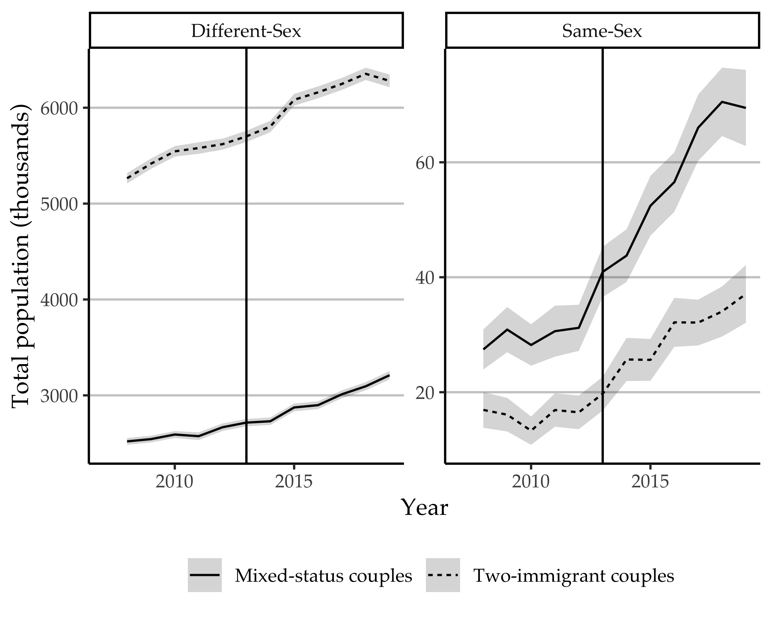

Figure 9.1: Estimated totals of different- and same-sex couples containing one (“mixed status”) or two immigrants, 2008-2019, with 95% confidence intervals. Vertical line placed at the year 2013, when DOMA was overturned.

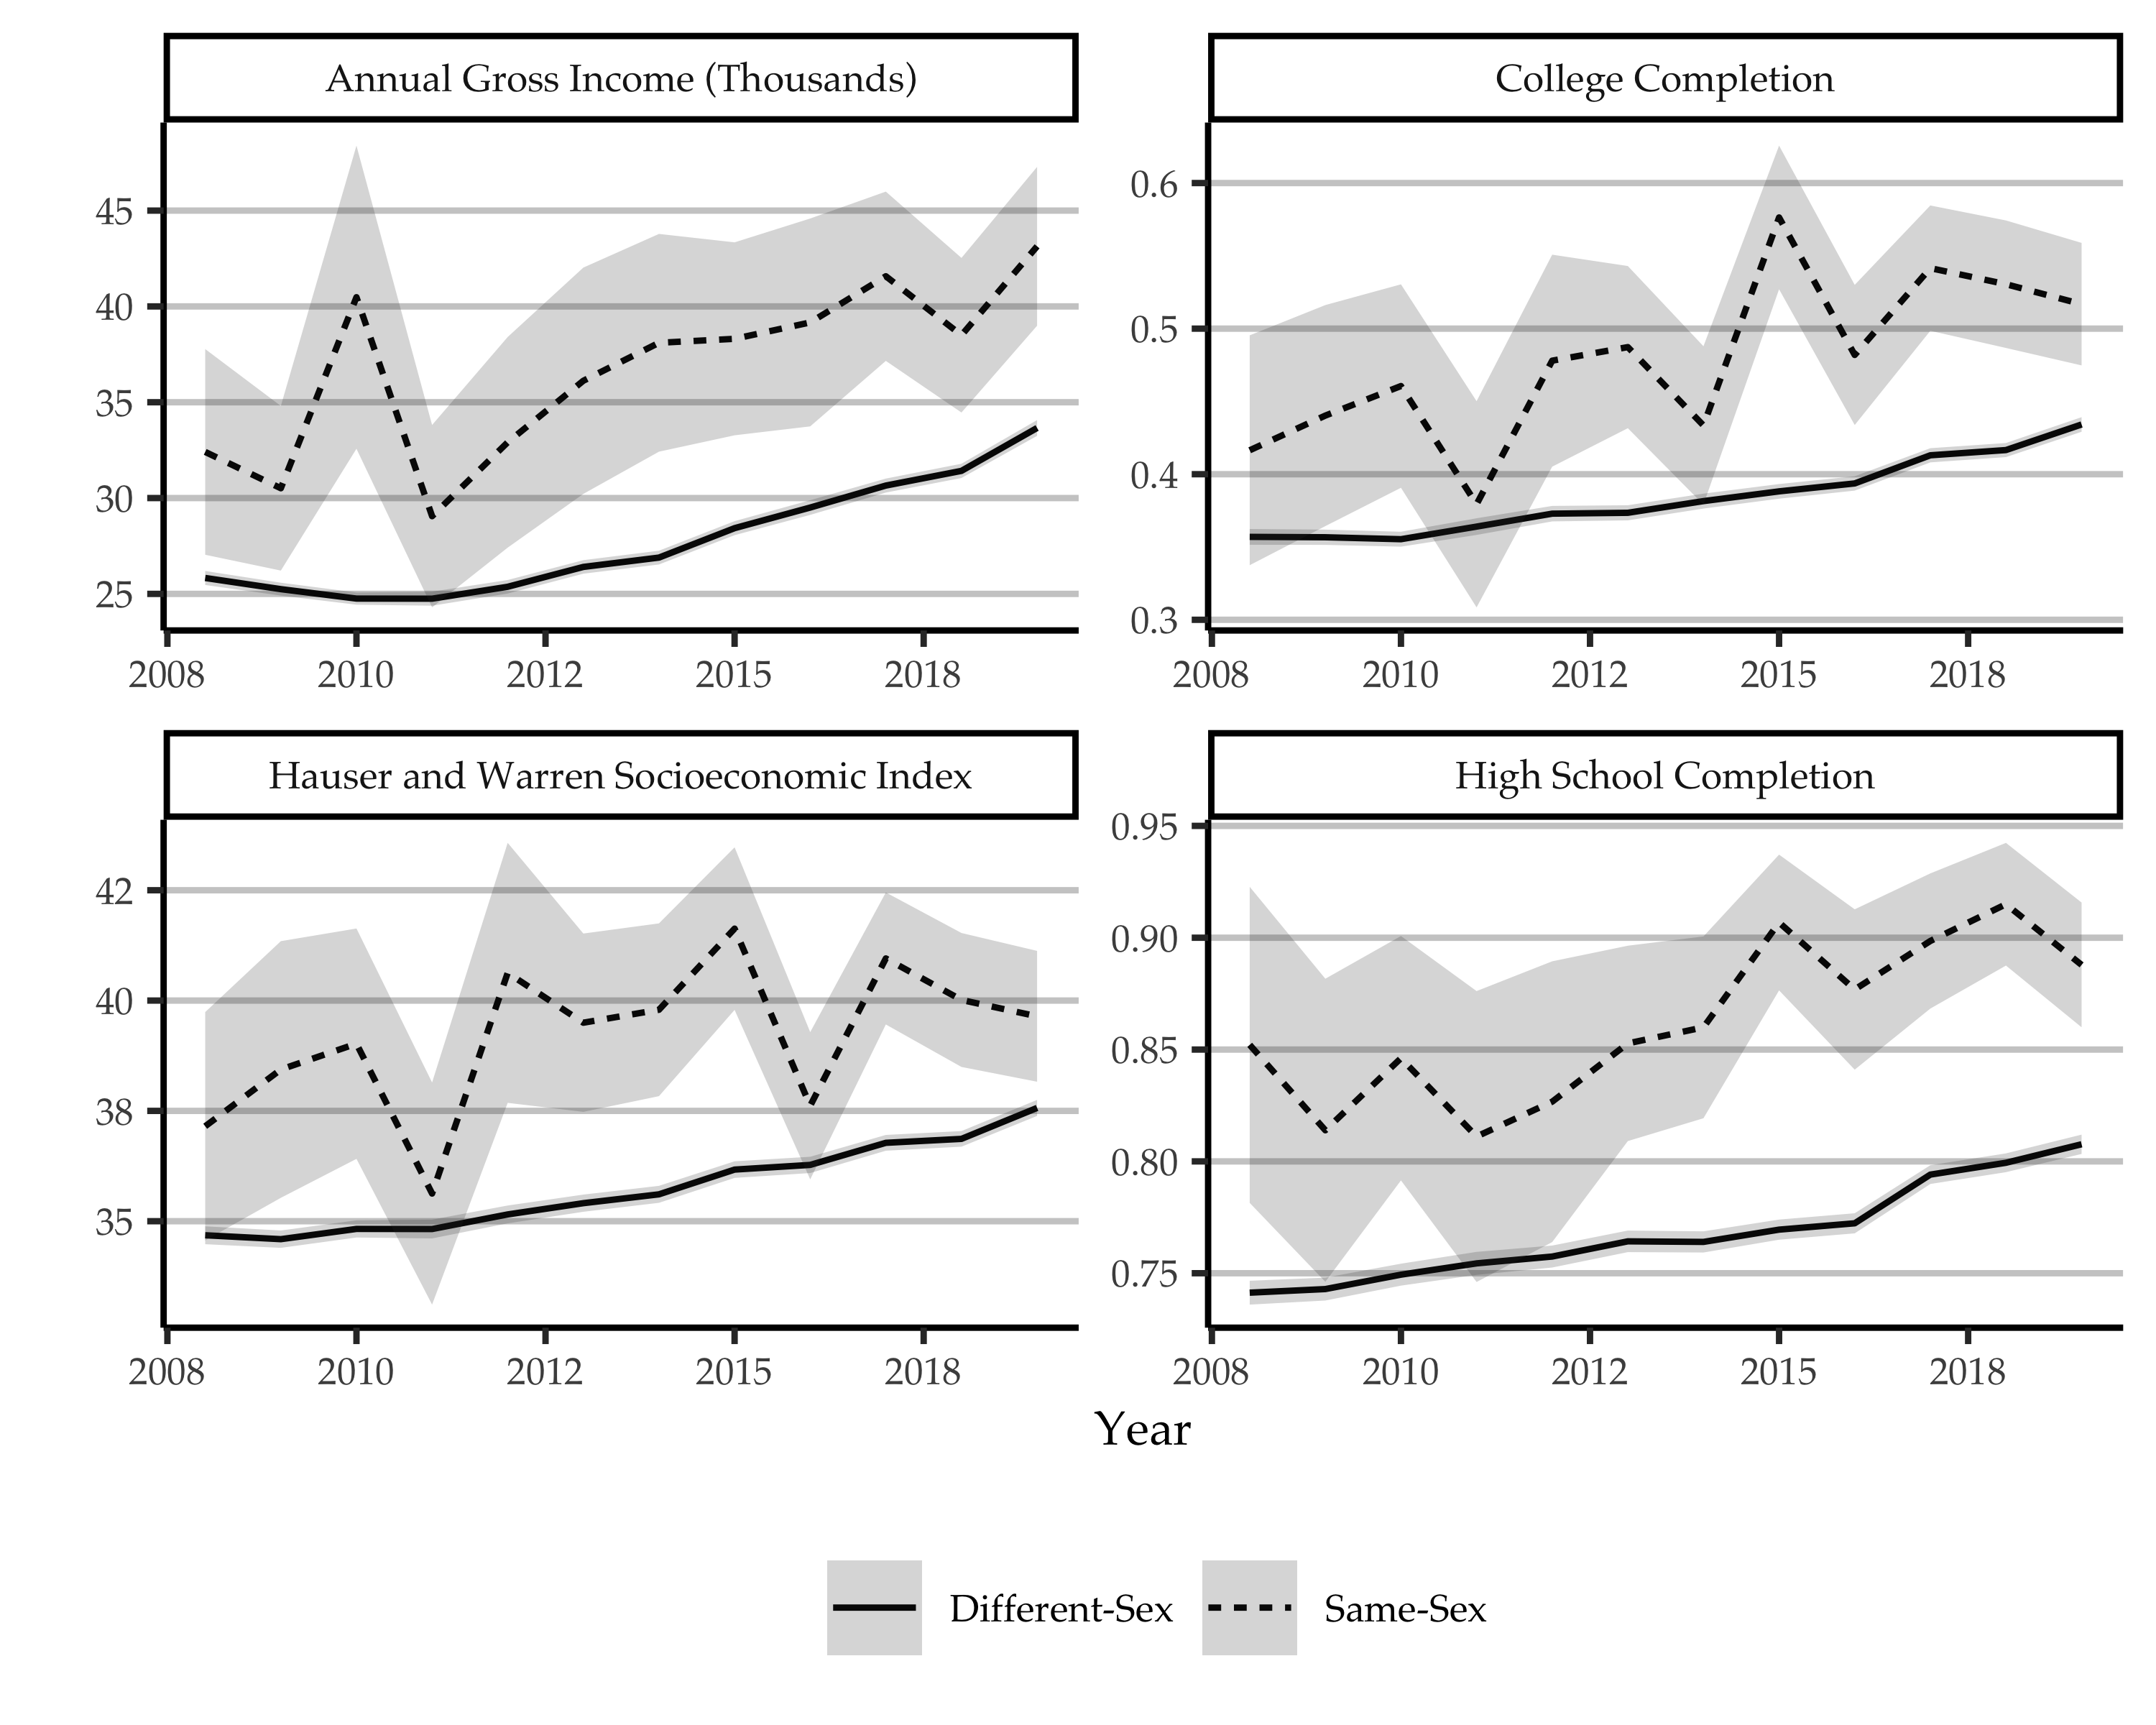

Figure 9.2: Individual descriptive statistics for immigrants in couples 2008-2019, with survey weights and 95% confidence intervals. Currency in thousands of 1999 dollars.

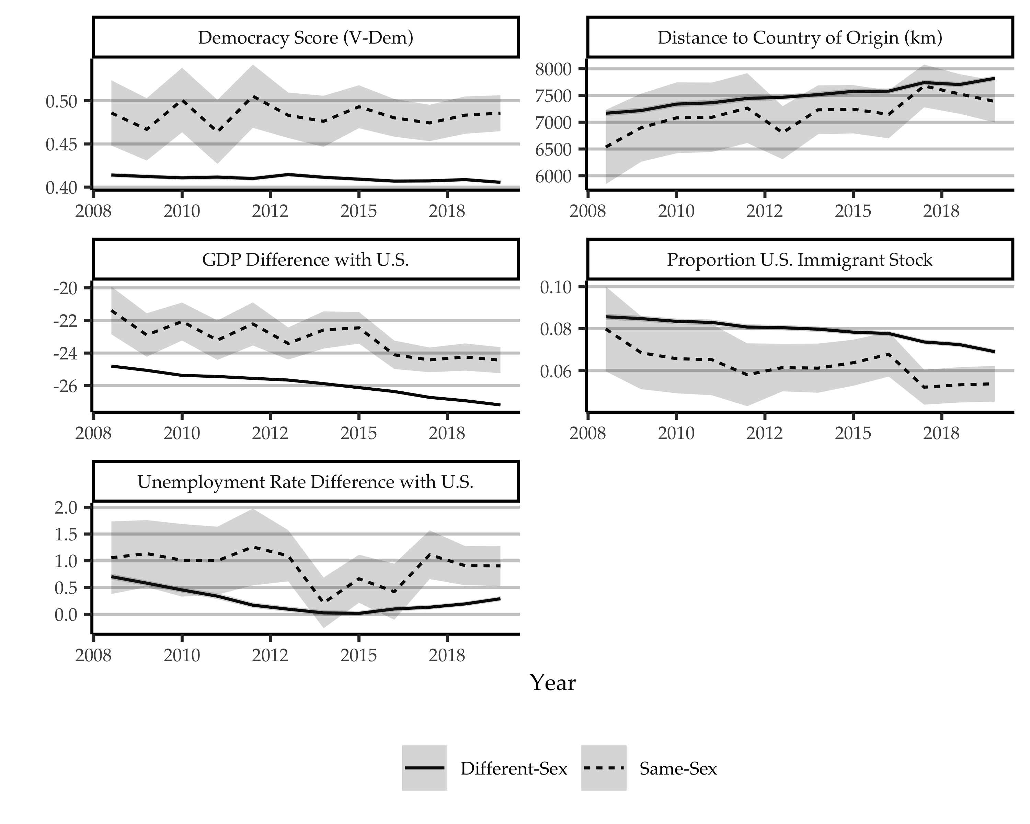

Figure 9.3: Origin country-level descriptive statistics for immigrants in couples 2008-2019, for year of migration, with survey weights and 95% confidence intervals. Currency in thousands of 1999 dollars.

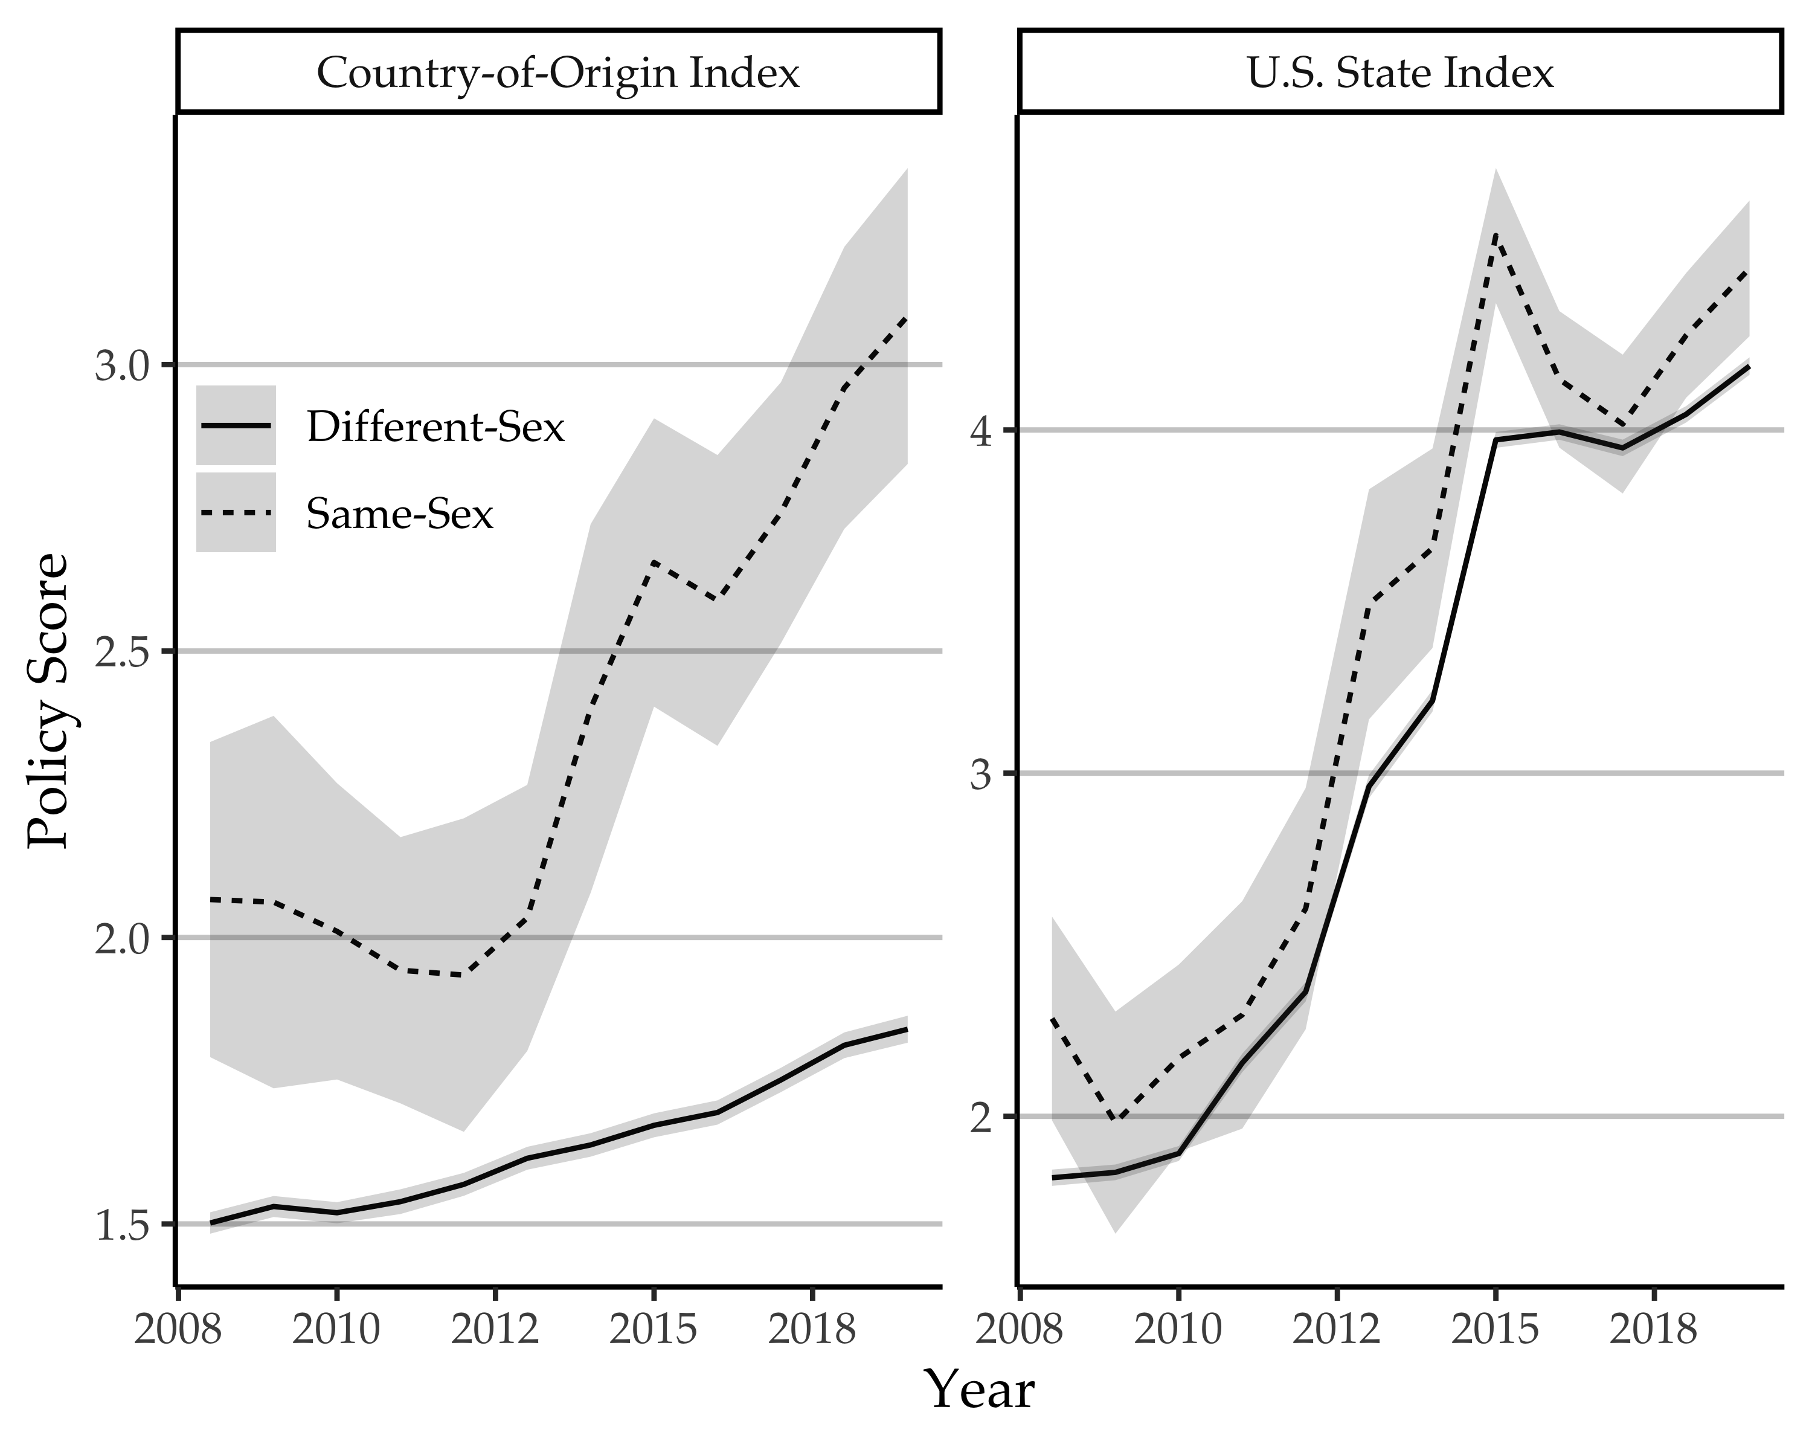

Figure 9.4: Mean country-of-origin and U.S. state policy index score for immigrants in same- and different-sex couples, 2008-2019, with 95% confidence intervals.

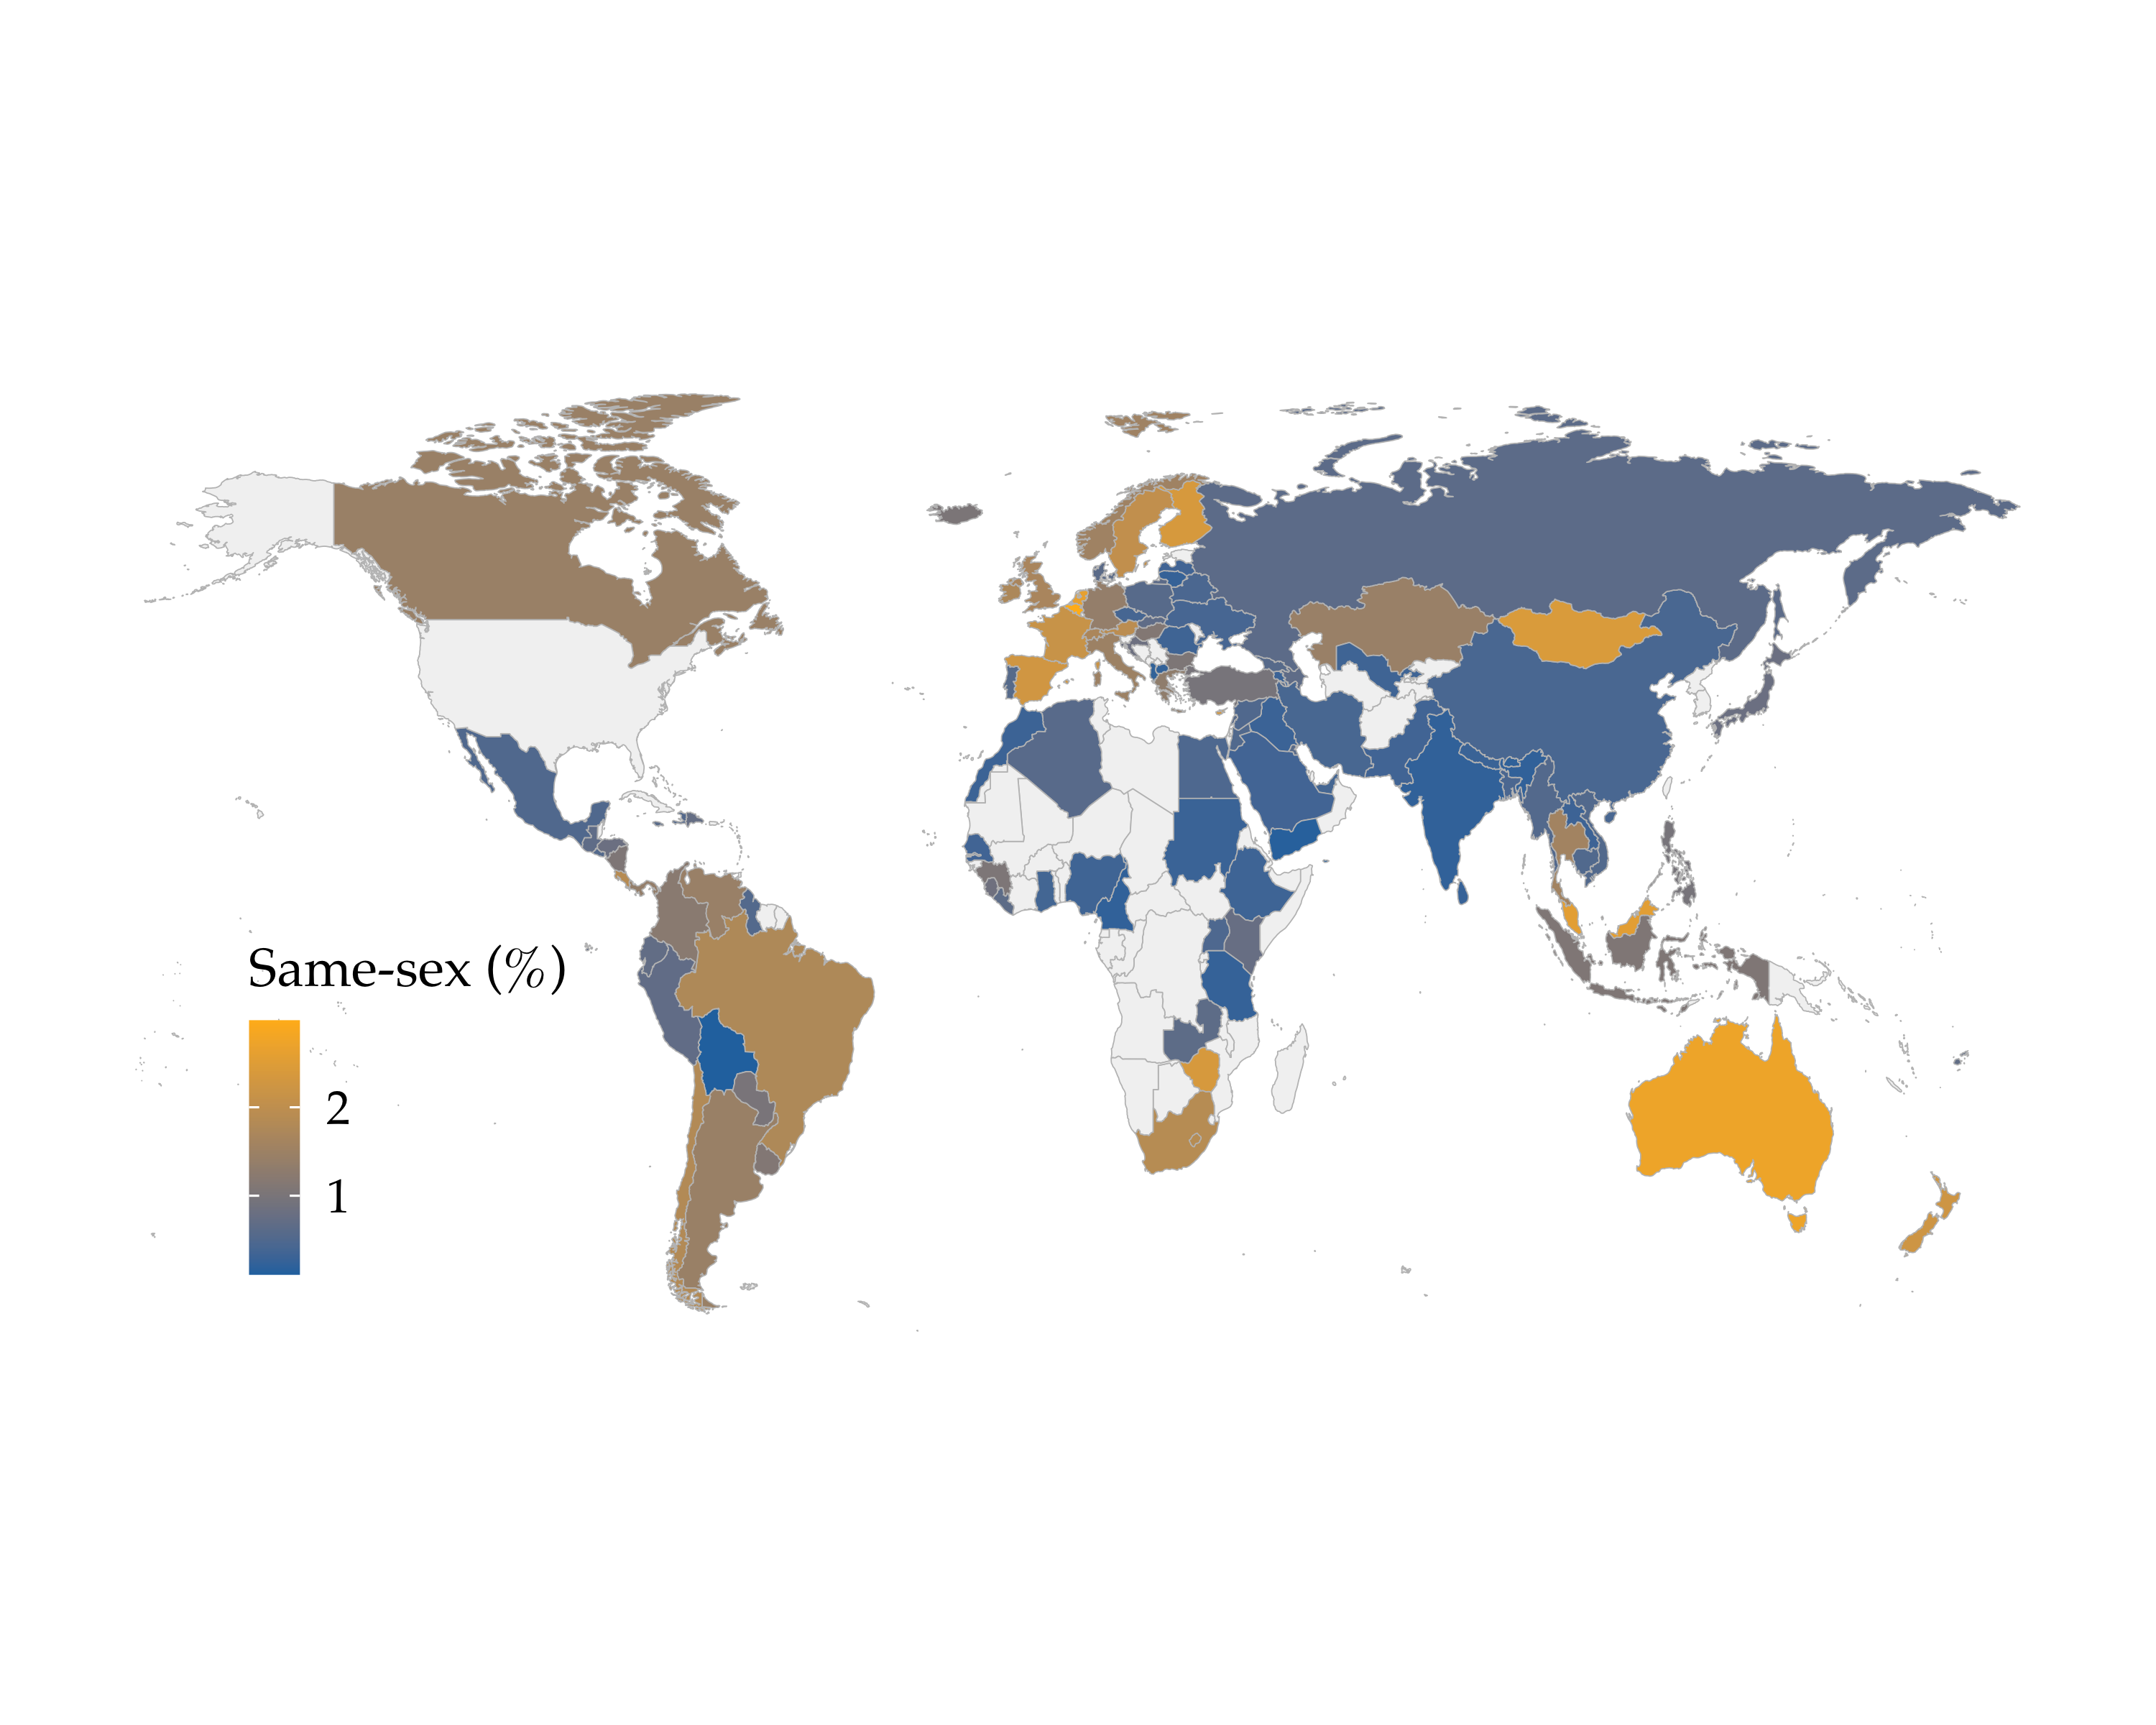

Figure 9.5: Percentage of immigrants to the U.S. in same-sex couples by country of origin, averaging over years of immigration from 1991 to 2019.

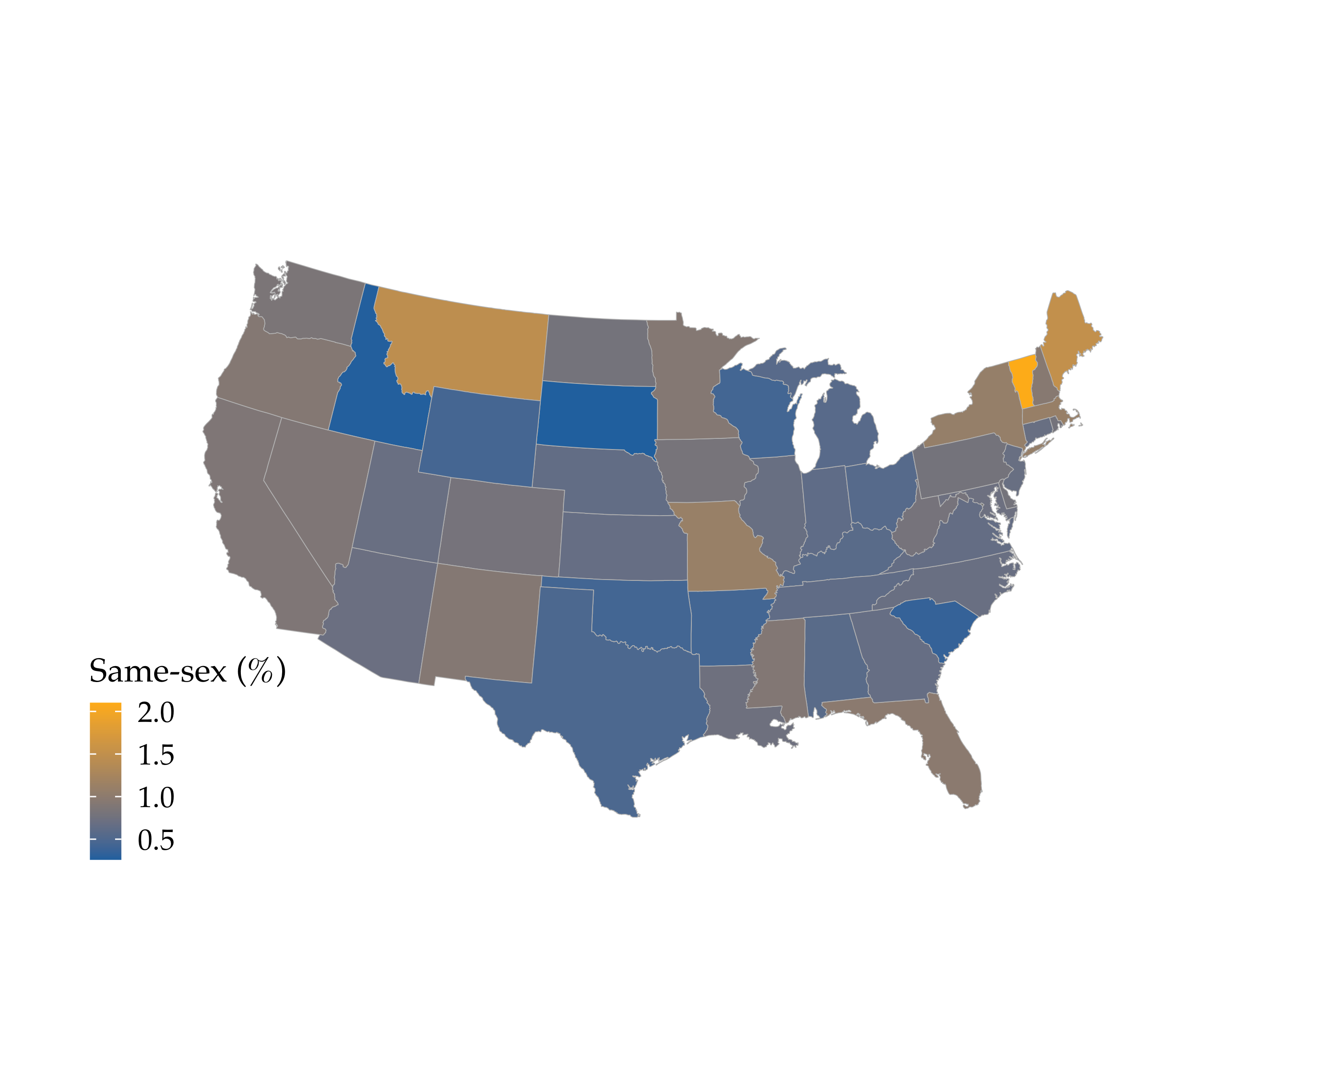

Figure 9.6: Percentage of immigrants in same-sex couples in U.S. states, averaging over ACS survey years 2008 to 2019.

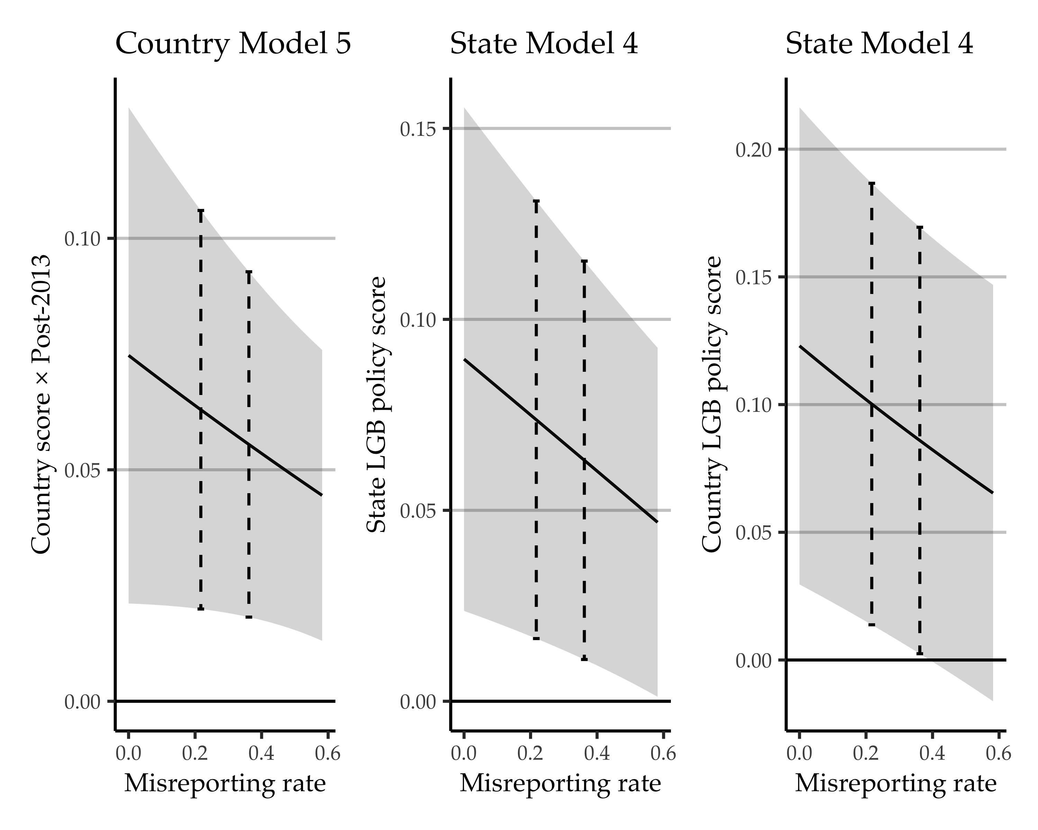

Figure 9.7: Coefficients for sending-country and U.S. state LGB policy context for fixed effects models in Tables 3 and 4, adjusted for hypothetical misreporting rates of married and unmarried same-sex couples in pre-2019 data. Ribbon shows 95 percent confidence intervals and dashed bars show estimated misreporting from the 2010 and 2016 U.S. Census Bureau tests on the ACS.

1. The exception is for for Figure 9.1, where we include those who immigrated in any year, at age 18 or older.
2. Beginning in 2019, the ACS added explicit “opposite-sex” and “same-sex” categories for spouses and unmarried partners, so data for this year should be in large part purged of sex misreporting (Walker & Taylor, 2021). See the Supplementary Material for more details.